Event Production - An Overview

Selecting the most appropriate event management company is crucial for ensuring the success of one's event. Whether you are planning a corporate gathering, a marriage, or a large public event, the proper partner could make most of the difference. One of the first considerations ought to be the company's experience with sound equipment hire. Quality sound is vital for any event, and a skilled company will have established relationships with sound hire providers. They'll make sure that the big event sound hire process is seamless, providing clear and reliable audio through your event. Another important factor could be the company's ability to offer comprehensive av production services. This includes sets from video projection and live streaming to lighting and stage setup. When evaluating potential partners, ask about their audio visual equipment hire capabilities. A company that gives audio visual for hire needs to have a range of modern equipment and experienced technicians to handle it. Browse the following site, if you're looking for more information concerning just smile productions.

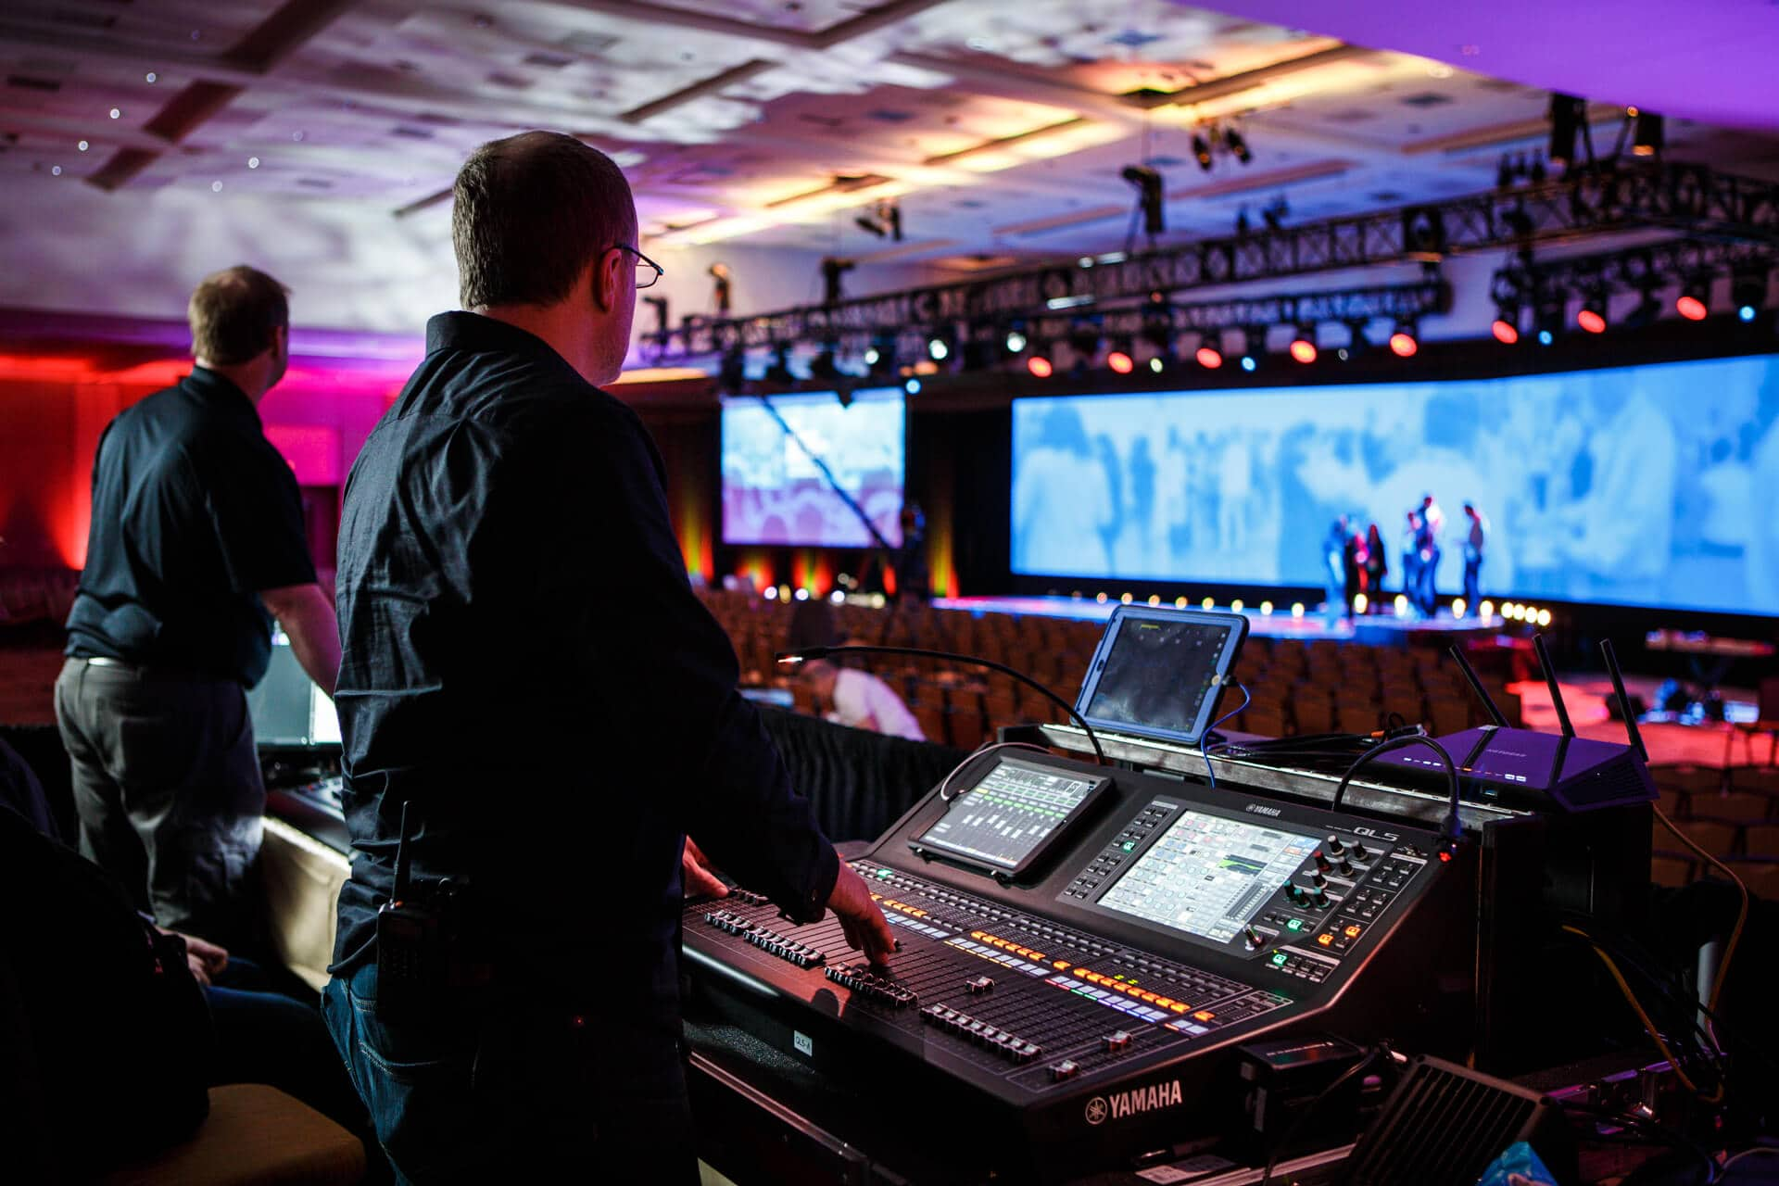

Ensuring they have experience in av equipments hire will give you confidence that the event's visual and audio components is likely to be handled professionally. Lighting is a critical element that could dramatically boost the atmosphere of one's event. Choose a company with expertise in event lighting hire. The proper lighting production company will learn how to use lighting to produce the required mood and highlight key aspects of the venue. For specific events like weddings, specialized wedding lighting hire can transform a place and ensure it is memorable. Ensure the business you decide on features a portfolio showcasing their lighting work on similar events to yours. Additionally, consider their overall event management capabilities. A great event management company will offer more than simply sound equipment hire and av production services. They will provide end-to-end solutions, including planning, coordination, and on-the-day management. This implies they can handle from venue selection and decoration to catering and entertainment. Comprehensive services ensure that every aspect of your event is covered, allowing you to focus on engaging together with your guests and enjoying the event.

Reputation and client reviews will also be essential whenever choosing an event management company. Look for testimonials and case studies that highlight their success in managing events just like yours. Positive feedback about their event sound hire, audio visual equipment hire, and event lighting hire services is an excellent indicator of these reliability and professionalism. Don't hesitate to ask for references or contact past clients to obtain a firsthand account of the experience with the company. In conclusion, selecting the right event management company involves consideration of several factors. Ensure they have expertise in sound equipment hire, av production services, and event lighting hire. Choose a company that provides comprehensive event management solutions and includes a strong reputation backed by positive client reviews. By selecting a company that excels in these areas, you may be confident your event is going to be well-planned, professionally managed, and highly successful. Purchasing a reliable event management partner will make sure your event runs smoothly and leaves a lasting impression on your guests.

