Deeper Look On Ear Gauge

Earrings have held cultural significance across various societies for centuries, serving as symbols of identity, status, and personal expression. In many cultures, earrings are more than mere adornments; they carry deep meanings and traditions. For example, in ancient Egypt, earrings were worn by both men and women as symbols of wealth and status. In India, earrings are integral to traditional attire and often signify marital status and social rank. Understanding the cultural significance of earrings can offer a fascinating glimpse into the values and histories of different societies, highlighting how these small pieces of jewelry play a big role in cultural expression. In modern times, the practice of ear stretching has gained popularity, especially in Western cultures. Stretch earrings and plugs tunnel are often seen as bold fashion statements. This practice, which involves gradually increasing the size of the earlobe piercing, has historical roots in various indigenous cultures. Today, many people use an earlobe stretching kit or a steel ear stretching kit to achieve this look. The best ear stretching kit includes everything needed to start the process safely, catering to both ear stretching kit beginners and those more experienced. Go to the below mentioned website, if you are hunting for more details about ear gauge.

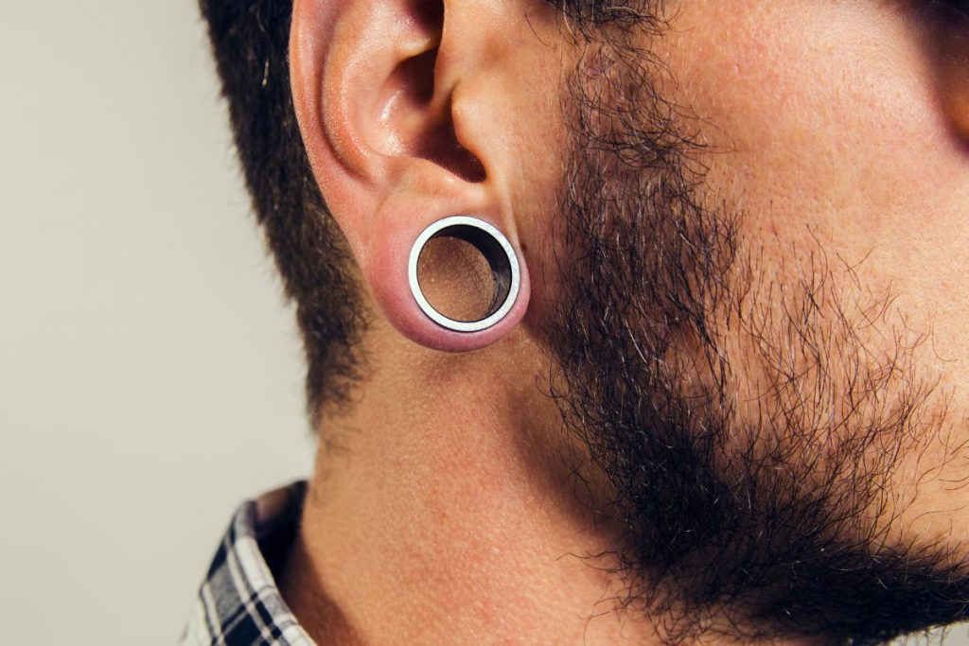

The trend has brought a new dimension to personal style and cultural expression. The use of flesh tunnels or ear tunnel plugs is another interesting aspect of ear stretching. These are hollow pieces of jewelry inserted into the stretched earlobe, creating a tunnel effect. Historically, flesh tunnels were worn by indigenous tribes in Africa and South America as symbols of tribal affiliation and rites of passage. Today, they are popular among those seeking to make a distinctive fashion statement. A gauge stretching kit is often used to achieve the desired size, ensuring the stretching process is gradual and safe. The availability of a large ear stretching kit allows enthusiasts to explore various sizes and styles, further personalizing their look. For those new to ear stretching, starting with an ear stretching starter kit or an ear stretching kit beginners is essential. These kits typically include tapers, plugs, and aftercare products to facilitate the stretching process. An ear gauge stretching kit ensures that each stage of stretching is done carefully, minimizing the risk of injury. By following the recommended guidelines and using the appropriate tools, individuals can safely achieve their desired look.

The practice of ear stretching not only enhances personal style but also connects modern wearers with ancient cultural practices, making it a unique blend of tradition and contemporary fashion. Caring for stretched ears is crucial to maintaining both the health of the earlobes and the appearance of the jewelry. Regular cleaning and proper aftercare are essential, especially when using products from an ear gauge kit or best ear stretching kit. This includes cleaning the jewelry and the piercing site to prevent infections and promote healing. Over time, as the earlobes heal and adapt to the new size, wearers can experiment with different types of jewelry, such as plugs tunnel and flesh tunnels. Maintaining proper hygiene and care ensures that the stretching process is safe and that the earlobes remain healthy. In conclusion, the cultural significance of earrings spans across different societies, each attributing unique meanings and traditions to this form of adornment. Modern practices such as ear stretching and the use of stretch earrings and ear tunnel plugs have roots in ancient traditions but have evolved into contemporary fashion statements. Using an ear stretching kit beginners or a large ear stretching kit helps enthusiasts achieve their desired look safely. Proper care and maintenance of stretched ears are essential to ensuring the health and longevity of both the piercings and the jewelry. By understanding and appreciating the cultural and historical context of earrings, individuals can embrace this timeless form of expression in a meaningful way.

