**An Overview Of Office Cleaning Services**

Mental health experts feel working in a clean place increases work productivity and helps with brainstorming new ideas. This is why many companies are collaborating with office cleaning services to ensure their workplace is disease and germ-free. A neat and clean workplace allows employees to relax and concentrate on their work. When employers offer clean surroundings to work, employees will feel their employers care for them and maintain the utmost hygiene. Additionally, taking commercial cleaning services is inexpensive and allows companies to save costs in the long run. They will have to deal with fewer worker leaves with germ-free surroundings. With more employees present, businesses can reach their daily, weekly and monthly targets efficiently. Commercial cleaning services help companies increase the employees’ productivity and morale. They can hire cleaning experts and ensure their place is sparkling clean. The top reason for the rising popularity of commercial cleaning services is they offer higher quality service as compared to regular cleaning. If you are seeking for additional details on [office cleaning services london](https://westclean.uk/office-cleaning-london/), click on the mentioned above website.

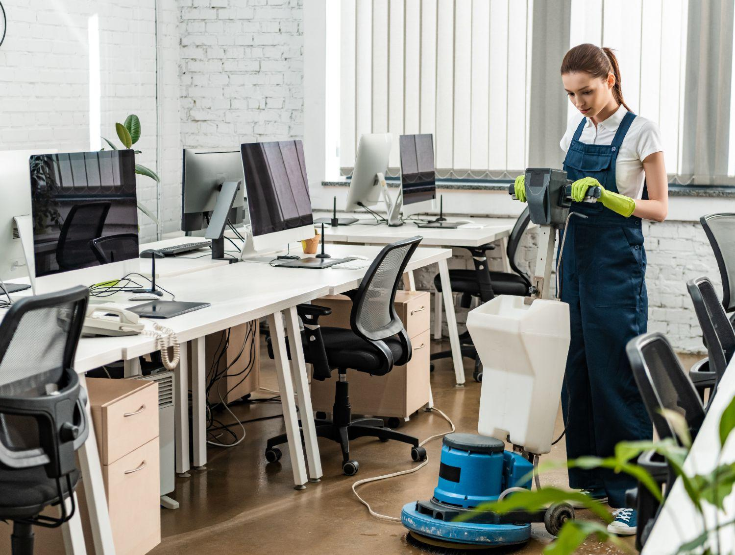

Commercial cleaning services use the best equipment and prime-quality cleaning ingredients to carry out their tasks. These products are unavailable in your local market. Apart from quality cleaning agents, commercial cleaning services have cleaning expertise and an experienced team by their side. Sometimes the germs are unseen by the naked eye, but they cause infections and diseases, which these professionals can very well take care of. An added advantage of commercial cleaning is it makes companies look more professional and enables them to make a positive first impression. People make perceptions about your company by a mere glance. If they see the place needs more cleaning and repairs, it makes your business look unprofessional. Work premises cleanliness is as essential just as any other aspect of your business. However, companies already have a lot of work on their hands. They must complete daily tasks, deal with new clients and look for future investments. In this hectic schedule, cleaning takes a backfoot.

This is why taking the services of commercial cleaning companies can help as they help their clients boost their reputation by killing disease-causing germs. Commercial cleaning services have been in the industry for a long time and work to take the stress off their clients' shoulders. They take care of everything for their clients, whether wiping the windows or disinfecting the floors. People can finalise a cleaning company that listens to their cleaning needs and offers suitable suggestions. Going for professional cleaning services allows companies to free up more space for files and documents. They can clear the clutter and organise their workstations. Companies can collaborate with commercial cleaning companies and get services within their budget. They can choose among a wide selection of cleaning services like janitorial, bathroom, ballroom and computer room cleaning or choose a combined cleaning package to save money. Cleaning companies have multiple custom cleaning services for all client needs. They provide businesses with the service they deserve without causing a financial strain.