An Overview Of End Of Tenancy Cleaning

Maintaining a clear and organized office is needed for a productive and healthy work environment. Implementing effective cleaning strategies can significantly enhance the workspace, boost employee morale, and improve efficiency. Engaging office cleaning services could be a game-changer in achieving a spotless office. These professionals ensure that each nook and cranny is cleaned, reducing clutter and promoting a hygienic atmosphere. Regular office cleaning prevents the accumulation of dust and germs, creating a healthy environment for employees. Moreover, a clean office projects a specialist image to clients and visitors, which makes it a worthy investment for just about any business. A crucial step to keep your workplace clean is to begin a daily routine. Including tidying up desks, organizing files, and wiping down surfaces. Encouraging employees to take responsibility because of their personal workspaces could make a significant difference. For more intensive cleaning, consider hiring professional house cleaners who specialize in office cleaning. They've the expertise and equipment to take care of tasks that rise above regular maintenance, such as for instance deep cleaning carpets and sanitizing high-touch areas. By delegating these tasks to professionals, you can ensure a consistently clean environment without disrupting daily operations. Another important aspect is managing waste effectively. Place adequate trash bins and recycling stations through the office to encourage proper disposal of waste. Browse the below mentioned site, if you're looking for more information concerning end of tenancy cleaning melbourne.

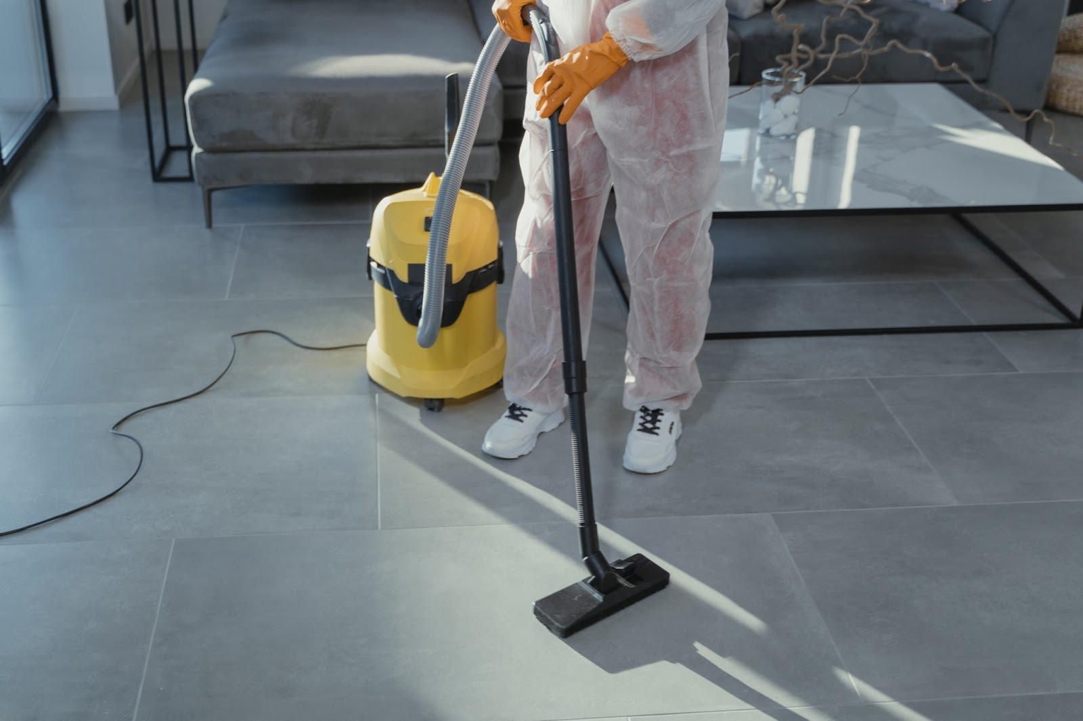

Regularly emptying these bins is vital to avoid overflow and unpleasant odors. Professional cleaning services are designed for these tasks efficiently, ensuring that waste is managed correctly. Additionally, consider implementing a green cleaning policy by utilizing eco-friendly products and practices. This not merely promotes a wholesome workplace but additionally aligns with environmental sustainability efforts. Many office cleaning services offer green cleaning options, which is often good for both the surroundings and employee health. Periodic deep cleaning is essential for maintaining the office's hygiene standards. Services like after builders cleaning and post construction cleaning are particularly useful after renovations or construction work. These specialized services ensure that all debris and dust are thoroughly removed, leaving work spotless and safe for employees to return. Similarly, end of tenancy cleaning and end of lease cleaning are crucial when moving offices. They ensure the room is left in pristine condition, which could assist in recovering the deposit and leaving a good impression on the property owner. Engaging professional cleaners for these tasks guarantees a thorough job, saving time and effort for the business. Organizing office space effectively can also donate to cleanliness. Utilize storage solutions like shelves, cabinets, and desk organizers to keep items within their designated places. This reduces clutter and makes cleaning easier. Encourage employees to adopt a clean-desk policy where they clear their desks at the conclusion of each day.

This not only helps in maintaining order but also makes regular cleaning by office cleaning services more efficient. An organized office reduces stress and improves productivity, as employees can very quickly find what they require without being distracted by clutter. Lastly, regular reviews and feedback on cleaning practices are essential. Assess the effectiveness of current cleaning routines and make adjustments as needed. Solicit feedback from employees in regards to the cleanliness of the work areas and common spaces. Addressing their concerns can cause improvements and make sure that any office remains a nice destination for a work. Partnering with reliable cleaning services that understand your office's unique needs can significantly enhance the general cleanliness and organization. They could provide tailored solutions, whether it's routine office cleaning, move out cleaning, or maybe more specialized tasks, ensuring your working environment remains pristine and inviting. In summary, maintaining a clean and organized office requires a variety of daily routines, professional cleaning, and effective waste management. Utilizing professional house cleaners and specialized services like after builders cleaning ensures a thorough way of cleanliness. An organized office not only enhances productivity but also creates a healthier work environment. By prioritizing cleanliness and engaging professional cleaning services, businesses can ensure their offices are always ready for work and welcoming to both employees and clients.

