A Synopsis Of Elopement Photographers

Choosing the right elopement service can make all the difference in creating a memorable and stress-free experience for your special day. The first step is to research and identify what you want from your elopement wedding. Do you prefer a simple ceremony in a beautiful location, or do you want an all-inclusive experience with every detail taken care of? Consider the number of guests you plan to invite, if any, and the type of setting that best reflects your personalities and relationship. Knowing your preferences will help you narrow down the options and find an elopement service that meets your needs. Once you have a clear idea of what you’re looking for, start researching elopement packages offered by various providers. Many services offer all-inclusive elopement packages that cover everything from the venue and officiant to flowers and photography. These packages can be a great way to simplify planning and ensure that all the essential elements are covered. Look for packages that offer flexibility and customization options, allowing you to tailor the details to your liking. Reading reviews and testimonials from other couples can also provide valuable insights into the quality of the service and the experiences of others. Are you searching for scotland elopement photographers? Browse the before talked about website.

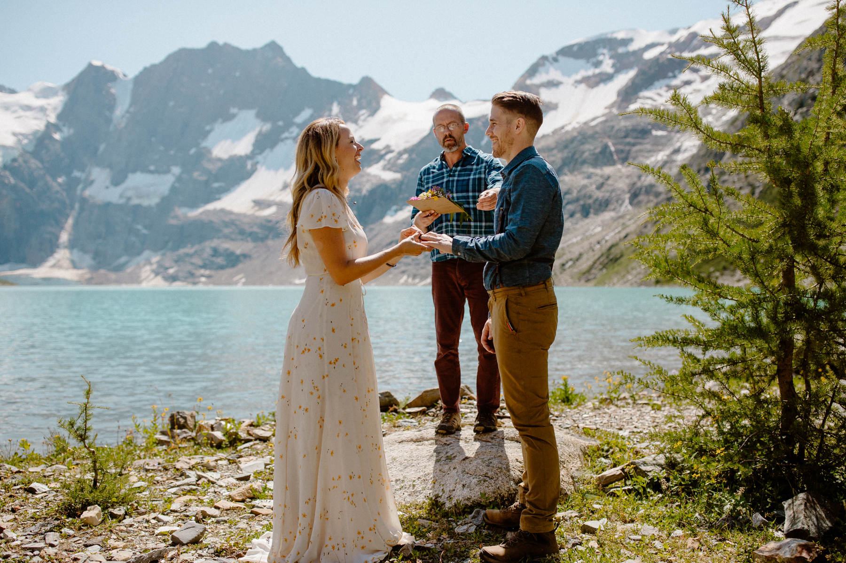

One of the most important aspects of an elopement is capturing the memories through photography. Choosing skilled elopement photographers is crucial for documenting your special day. When selecting a photographer, review their portfolio to ensure their style matches your vision. Experienced elopement photographers will know how to work with natural light, landscapes, and intimate moments to create stunning images. It’s also important to feel comfortable with your photographer, as they will be capturing some of your most personal and emotional moments. Arrange a meeting or consultation to discuss your expectations and ensure a good fit. Another factor to consider when selecting an elopement service is the level of support and guidance they provide. Planning an elopement wedding can be less stressful than a traditional wedding, but it still requires careful coordination. Look for services that offer comprehensive planning assistance, from securing permits and booking vendors to organizing travel and accommodation. The best elopement packages will include a dedicated planner who can help you navigate the logistics and handle any challenges that arise.

This support can be invaluable, especially if you’re planning an elopement in a destination far from home. Finally, consider the overall value and transparency of the elopement packages you’re evaluating. It’s important to understand exactly what is included in each package and to be aware of any additional costs that may arise. Request a detailed breakdown of the services and fees to avoid any surprises. Compare the offerings of different providers to find the package that best fits your budget and requirements. Remember that the cheapest option is not always the best; prioritize quality and reliability to ensure a seamless and enjoyable elopement experience. In conclusion, choosing the right elopement service involves careful consideration of your preferences, thorough research of available elopement packages, and selecting the best elopement photographers to capture your day. Ensure the service offers comprehensive support and guidance, and evaluate the value and transparency of the packages. By taking these steps, you can find an elopement service that provides a beautiful, stress-free, and memorable experience for your special day.

