**A Look At Lifeboat For Sale**

Regular lifeboat maintenance is essential to ensuring the safety of everyone on board a vessel. Lifeboats are critical in emergencies, providing a reliable means of escape and survival. Neglecting their upkeep can lead to malfunctions when they are most needed. Regular lifeboat inspection helps identify potential issues before they become serious problems. Inspections often include checking for structural damage, verifying the functionality of release mechanisms, and ensuring that all equipment, such as radios and flares, is in working order. Routine maintenance can prevent catastrophic failures and increase the likelihood of lifeboat survival during an emergency. Lifeboat maintenance services are indispensable for the maritime industry, especially for large vessels like oil rigs. Companies offering these services provide expertise in handling the complexities of lifeboat systems. These professionals are skilled in various aspects of lifeboat maintenance, from mechanical repairs to electronic system checks. For an oil rig, having a lifeboat for sale that meets all safety standards is crucial. Regular maintenance ensures that these lifeboats are always ready for deployment, enhancing the safety of all personnel. Make a search on the following site, if you are searching for additional information regarding [lifeboat for sale](https://www.survivalsystemsinternational.com/uk/twinfall-lifeboats/).

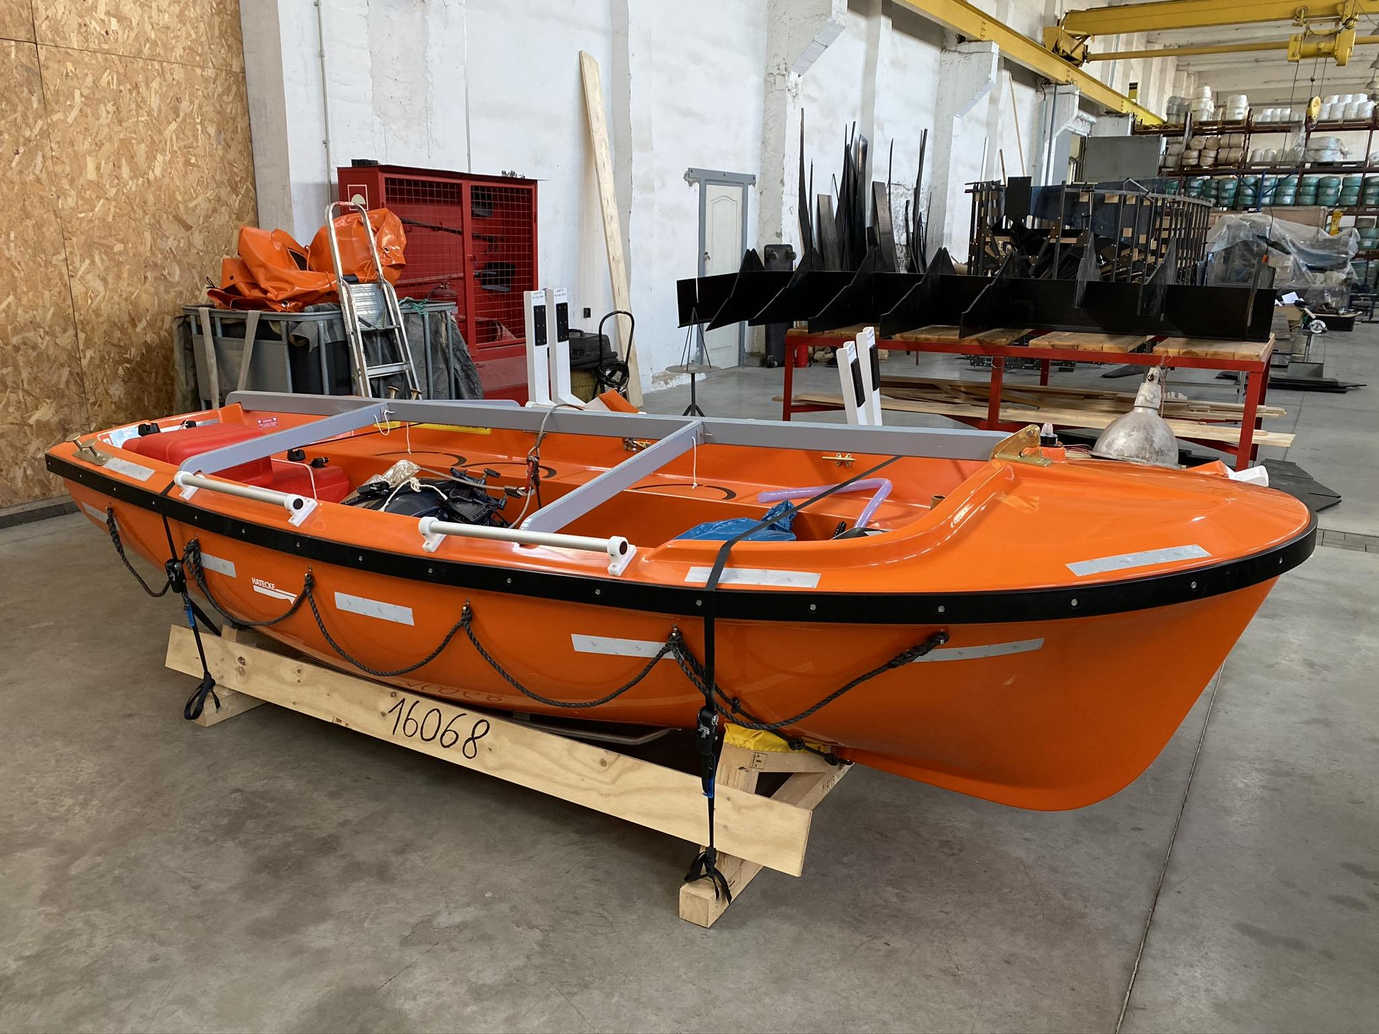

The availability of lifeboats and life rafts is a critical factor in emergency preparedness, significantly impacting overall safety outcomes. The market for life boats for sale is diverse, catering to different types of vessels and their specific needs. When purchasing a lifeboat for sale, it is important to consider factors such as capacity, design, and compliance with international safety standards. Regular lifeboat inspection and maintenance are vital to ensure that these lifeboats remain functional over time. Buyers should look for reputable sellers who offer comprehensive lifeboat maintenance services as part of the package. Ensuring that a newly acquired lifeboat is in top condition can prevent future issues and guarantee its reliability in emergencies. Lifeboat survival depends heavily on the condition of the lifeboats themselves. In an emergency, the last thing anyone wants is a malfunctioning lifeboat. Proper maintenance includes checking the hull for cracks, ensuring the engine starts reliably, and verifying that all onboard equipment is present and operational. Life rafts also require regular maintenance and inspection to ensure they inflate properly and contain necessary supplies. For those seeking a life raft for sale, it is crucial to choose products from trusted manufacturers who adhere to stringent safety standards.

Regular upkeep of these survival crafts ensures they perform effectively when needed. Oil rigs and other large vessels often have multiple lifeboats and life rafts. Given their critical role, it is not surprising that there is a steady demand for oil rig lifeboat for sale. These lifeboats must be maintained rigorously due to the harsh marine environments they operate in. Regular lifeboat maintenance includes corrosion checks, mechanical system tests, and safety gear verification. Companies that specialize in lifeboat maintenance services provide valuable support to ensure that all life-saving equipment is ready for immediate use. This proactive approach to maintenance helps safeguard lives and assets in the maritime industry. In conclusion, the importance of regular lifeboat maintenance cannot be overstated. Ensuring that lifeboats and life rafts are in optimal condition is crucial for safety at sea. Routine lifeboat inspection and maintenance services provided by skilled professionals help identify and rectify issues promptly. For those in the market, choosing a lifeboat for sale from reputable sellers guarantees compliance with safety standards. Whether for an oil rig or any other vessel, maintaining these life-saving crafts is a vital part of maritime safety protocols. Reliable lifeboats and life rafts significantly enhance the chances of survival in emergency situations.