3D Reverse Engineering - What You Must Learn

In today's competitive market, CAD scanning services have become essential in product development. By integrating 3D scanning into the design process, companies can achieve significant improvements in efficiency and accuracy. CAD scanning allows for the rapid capture of detailed geometric data, transforming physical objects into digital models. This digital transformation streamlines workflows, reduces errors, and enhances collaboration among team members. With the ability to quickly and accurately convert physical prototypes into digital assets, product developers can iterate designs faster, ultimately accelerating time to market and reducing costs associated with traditional design methods. 3D scanning and reverse engineering are crucial components of modern product development. By utilizing 3D laser scanning services, engineers can capture precise measurements and details of existing objects, which can then be used for 3D reverse engineering. This process is invaluable for reproducing complex parts and improving upon existing designs. 3D measurement services provide the necessary data to ensure that new designs fit perfectly with existing components, minimizing the risk of errors and rework. The integration of 3D scanning services into the development process not only improves accuracy but also facilitates innovation by enabling designers to explore new possibilities and create more complex and intricate designs. The application of 3D laser scanning reverse engineering techniques offers numerous benefits across various industries. Check out the following site, if you're searching for more details concerning 3d reverse engineering.

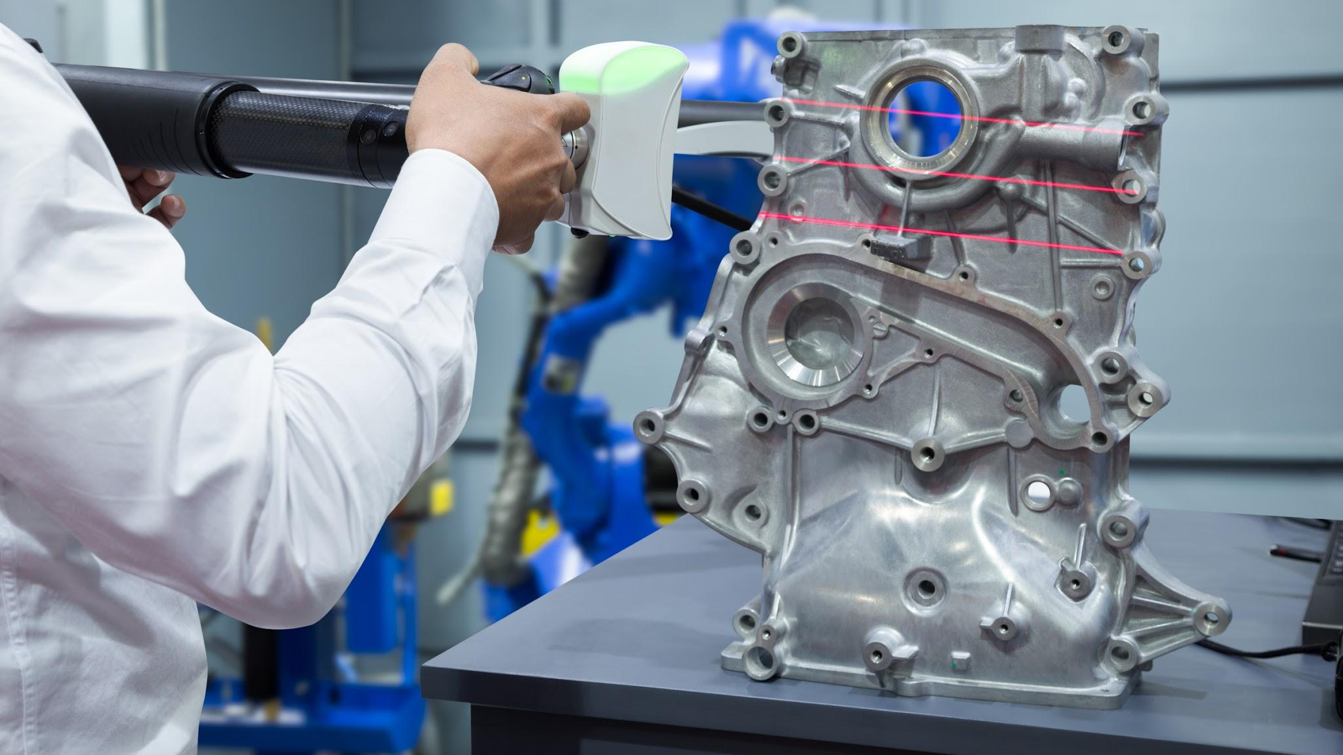

For instance, in the automotive and aerospace sectors, laser scanning services are used to create accurate digital models of intricate components. These models are essential for quality control, ensuring that parts meet stringent industry standards. Additionally, 3D scan reverse engineering helps in the restoration and maintenance of legacy parts that may no longer be in production. By digitizing these components, manufacturers can produce exact replicas or make necessary modifications to enhance performance, thus extending the lifespan of valuable equipment and machinery. CAD scanning is not limited to industrial applications; it also plays a significant role in the consumer product sector. Companies offering 3D measurement services can assist in designing and improving products such as household appliances, electronics, and even fashion items. By employing 3D scanning services, designers can create highly accurate prototypes and refine their designs before mass production. This reduces the likelihood of defects and improves the overall quality of the final product. Furthermore, the ability to perform 3D scanning and reverse engineering allows for customization and personalization of products, catering to specific customer needs and preferences, thereby enhancing customer satisfaction and brand loyalty.

The healthcare industry also benefits greatly from 3D scanning and 3D reverse engineering. Medical professionals use CAD scanning services to create precise digital models of anatomical structures, aiding in the development of prosthetics, orthotics, and surgical implants. These 3D laser scanning services enable the production of patient-specific devices that fit perfectly and function optimally. Additionally, 3D measurement services are used in medical research and education, providing accurate and detailed models for study and training purposes. The ability to accurately replicate biological structures enhances the effectiveness of medical treatments and contributes to the advancement of medical science. In conclusion, CAD scanning services have revolutionized product development across various industries. By leveraging 3D scanning technologies, companies can improve the accuracy and efficiency of their design processes. The integration of 3D scanning services and 3D laser scanning reverse engineering into workflows not only streamlines development but also fosters innovation and enhances product quality. Whether in industrial manufacturing, consumer products, or healthcare, the benefits of 3D measurement services and laser scanning services are evident. As technology continues to advance, the adoption of CAD scanning will undoubtedly play a crucial role in shaping the future of product development, enabling companies to stay competitive and meet the evolving demands of the market.

