**Precise Study On The Fat Freezing Treatment**

Aesthetic treatments have gained significant popularity over the years due to their ability to enhance physical appearance and boost self-confidence. The science behind popular aesthetic Treatments delves into the mechanisms and benefits of these procedures, shedding light on how they work and why they are effective. Among the most talked-about treatments are the p shot, also known as the Priapus Shot, and penis fillers. These treatments are particularly popular in cities like London, where advanced medical procedures are readily accessible. Understanding the science behind these treatments can help individuals make informed decisions about their aesthetic goals. The p shot London is a revolutionary treatment designed to improve sexual performance and health in men. The procedure involves injecting platelet-rich plasma (PRP) derived from the patient’s own blood into the penile tissues. This promotes tissue regeneration and increased blood flow, resulting in enhanced sexual function and sensitivity. The science behind the priapus shot London lies in the growth factors present in PRP, which stimulate cellular repair and growth. Are you hunting for a [fat freezing kent](https://www.elite-aesthetics.co.uk/treatments/fat-freezing/)? Check out the earlier mentioned site.

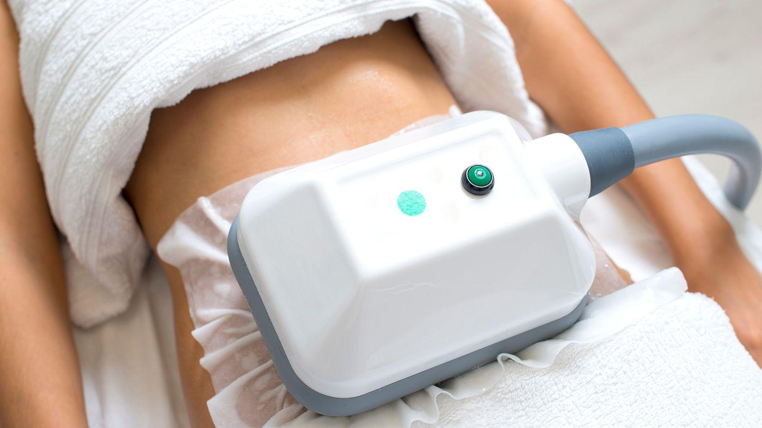

This natural and minimally invasive treatment is gaining traction as more men seek effective solutions for erectile dysfunction and other sexual health issues. Penis fillers are another popular aesthetic treatment aimed at enhancing the size and shape of the penis. These fillers, typically composed of hyaluronic acid, are injected into the penile shaft to add volume and improve symmetry. The procedure is relatively quick and offers immediate results, making it an attractive option for men seeking a non-surgical enhancement. In penis fillers London, the emphasis is on safety and achieving natural-looking results. The science behind penile fillers London is rooted in the biocompatibility of hyaluronic acid, which integrates seamlessly with the body’s tissues, providing both aesthetic and functional benefits. In addition to treatments for sexual health and enhancement, body contouring procedures like fat freezing are also in high demand. Fat freezing Kent, also known as cryolipolysis, targets and eliminates stubborn fat cells by exposing them to extremely cold temperatures. This process triggers apoptosis, or cell death, leading to a gradual reduction in fat over the following weeks. Locations such as fat freezing Maidstone and fat freezing Dartford offer this innovative treatment to individuals looking to sculpt their bodies without invasive surgery.

The science behind fat freezing is well-established, with clinical studies demonstrating its efficacy and safety in reducing localized fat deposits. Another advanced body contouring treatment is 3D Lipo, which combines multiple technologies to target fat, tighten skin, and reduce cellulite. 3D Lipo Kent utilizes ultrasound, radiofrequency, and cryolipolysis to achieve comprehensive body contouring results. The combination of these modalities enhances the effectiveness of the treatment, providing noticeable improvements in body shape and texture. 3D Lipo Essex and 3D Lipo Dartford are popular destinations for those seeking this multi-faceted approach to fat reduction and skin tightening. The science behind 3D Lipo lies in its ability to address multiple layers of tissue, offering a holistic solution for body contouring. In conclusion, understanding the science behind popular aesthetic treatments is crucial for anyone considering these procedures. Whether it’s the p shot, penis fillers, or body contouring treatments like fat freezing and 3D Lipo, knowing how these treatments work can help individuals make informed choices. The Science Behind Popular Aesthetic Treatments: What You Need to Know highlights the importance of these advanced procedures in achieving desired aesthetic goals safely and effectively. By staying informed about the latest advancements in aesthetic medicine, individuals can confidently embark on their journey to enhance their appearance and boost their self-confidence.