**Information On Retreat For Weight Loss**

Women's wellbeing retreats have emerged as powerful catalysts for personal growth, offering a sanctuary for women to prioritize self-care and holistic wellness. These retreats provide a nurturing environment where participants can disconnect from the demands of daily life and focus on rejuvenating their mind, body, and spirit. Women's wellbeing retreats encompass a range of activities, from yoga and meditation sessions to wellness workshops and holistic therapies. By immersing themselves in these transformative experiences, women gain valuable insights, tools, and practices to enhance their overall wellbeing and empower themselves on a profound level. One of the key benefits of women's wellbeing retreats is the opportunity for self-discovery and inner exploration. Through guided activities and introspective practices, participants gain a deeper understanding of themselves, their values, and their aspirations. This self-awareness fosters personal growth, resilience, and a sense of purpose, empowering women to make positive changes in their lives and relationships. If you're looking for additional info on [retreat for weight loss](https://www.thebodyretreat.co.uk/retreat/weight-loss-retreat/), look at the earlier mentioned site.

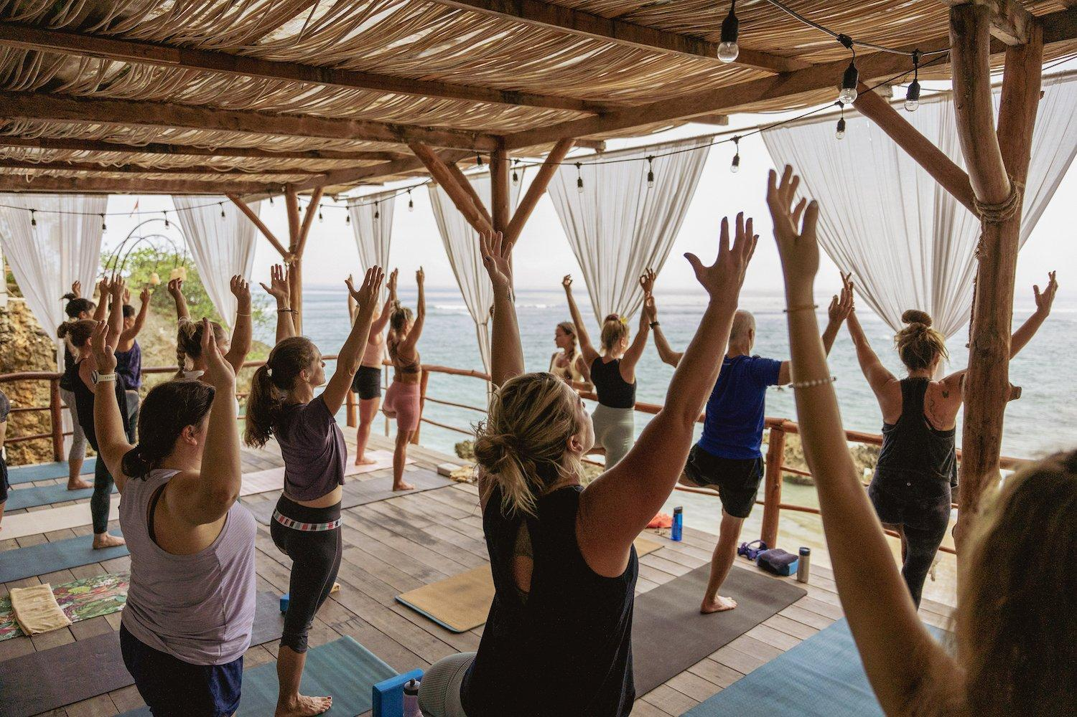

The supportive community and nurturing environment of these retreats create a safe space for women to explore, heal, and transform. Moreover, women's wellbeing retreats focus on holistic wellness, addressing the interconnectedness of mind, body, and spirit. Participants engage in physical activities that promote fitness, flexibility, and vitality, such as yoga, hiking, and dance. They also learn about nutrition, healthy lifestyle choices, and stress management techniques to support their overall health and wellbeing. By embracing a holistic approach, these retreats empower women to cultivate balance, resilience, and a renewed sense of vitality in their lives. Another significant aspect of women's wellbeing retreats is the emphasis on mental and emotional wellness. Participants engage in mindfulness practices, meditation, and mindfulness-based therapies to cultivate inner peace, emotional resilience, and mental clarity. These practices help women navigate life's challenges with greater ease, manage stress and anxiety, and foster positive mental health habits. The nurturing environment of the retreat allows women to explore their emotions, release emotional blocks, and cultivate a deeper sense of self-compassion and self-love.

Furthermore, women's wellbeing retreats offer a break from the hustle and bustle of everyday life, allowing participants to recharge and rejuvenate. The serene natural settings, comfortable accommodations, and nourishing meals create an ideal environment for relaxation and renewal. Participants have the opportunity to disconnect from technology, reconnect with nature, and engage in activities that bring them joy and fulfillment. This rejuvenation process supports mental clarity, creativity, and overall wellbeing, setting the stage for positive transformation and personal growth. In conclusion, women's wellbeing retreats have a profound impact on women's lives by empowering them to prioritize self-care, cultivate holistic wellness, and embrace personal growth. These retreats offer a transformative experience that encompasses physical, mental, emotional, and spiritual wellbeing, providing valuable tools and practices for sustainable self-improvement. By participating in women's wellbeing retreats, women gain a deeper understanding of themselves, enhance their resilience, and create positive shifts in their lives. The nurturing environment, supportive community, and holistic approach of these retreats make them powerful platforms for empowerment, healing, and transformation.