**Important Things About Printing Service**

The evolution of digital printing has revolutionized the printing industry, bringing about significant changes in how businesses and individuals produce printed materials. Digital printing technology has enabled faster production times, higher quality outputs, and more cost-effective solutions. Hemel printers have embraced these advancements, providing a wide range of services that cater to the growing demands of the market. The flexibility and efficiency offered by digital printing have made it a popular choice for various printing needs, from small-scale personal projects to large-scale commercial endeavors. One of the most notable changes brought about by digital printing technology is the ability to produce high-quality prints with exceptional detail and color accuracy. Printers Hemel Hempstead and other local providers have invested in state-of-the-art digital printing equipment to meet these standards. This technology allows for precise control over the printing process, ensuring that each print job meets the client's specifications. The result is a finished product that looks professional and polished, which is essential for businesses looking to make a strong impression with their printed materials. Digital printing has also significantly reduced the turnaround times for printing projects. Make a search on the following site, if you are searching for additional information concerning [printers hemel hempstead](https://gtprintanddesign.co.uk/).

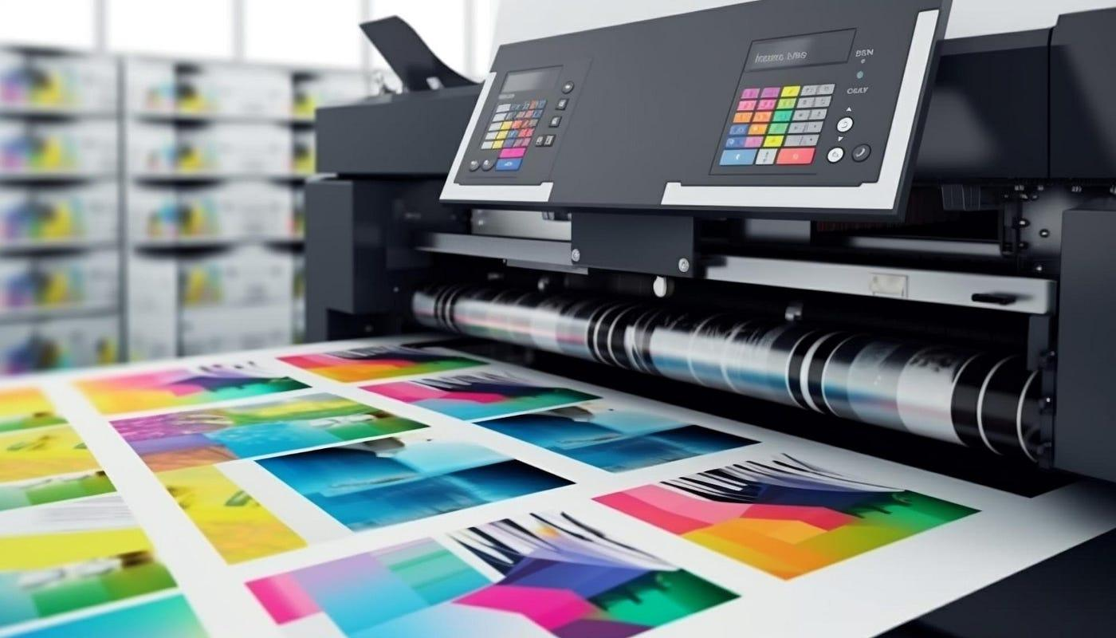

In the past, traditional printing methods required lengthy setup processes and often resulted in long wait times for completion. However, with digital printing, printers Hertfordshire can quickly and efficiently produce high-quality prints on demand. This speed and efficiency are particularly beneficial for businesses that need to meet tight deadlines or produce materials for time-sensitive events. The ability to print on demand also reduces waste, as there is no need to produce large quantities of prints that may not be used. Another advantage of digital printing is its cost-effectiveness, especially for small print runs. Traditional printing methods often involved high setup costs, making them less economical for smaller projects. Digital printing eliminates many of these setup costs, allowing Hemel printers to offer competitive pricing for both small and large print jobs. This affordability has opened up new opportunities for businesses and individuals to produce high-quality printed materials without breaking the bank. Additionally, digital printing allows for easy customization, enabling clients to create personalized prints that cater to their specific needs. The versatility of digital printing extends beyond traditional paper prints. Modern digital printers can handle a wide variety of materials, including fabric, metal, glass, and plastic. This versatility allows printers Hemel Hempstead to offer a broader range of services, such as printing on promotional items, signage, and packaging.

Businesses can take advantage of this capability to create cohesive and impactful branding across different mediums. The ability to print on various materials also opens up creative possibilities for artists and designers looking to experiment with different textures and finishes. As digital printing technology continues to evolve, the future of the printing industry looks promising. Innovations such as 3D printing and advancements in ink and substrate technology are set to further expand the capabilities of printers Hertfordshire and beyond. These developments will likely lead to even higher quality prints, faster production times, and more sustainable printing practices. As businesses and consumers continue to demand more from their printed materials, digital printing will remain at the forefront of the industry, driving innovation and setting new standards for quality and efficiency. In conclusion, the evolution of digital printing has transformed the printing industry, offering numerous benefits such as high-quality prints, faster turnaround times, cost-effectiveness, and versatility. Hemel printers, along with printers Hemel Hempstead and printers Hertfordshire, have embraced these advancements to meet the diverse needs of their clients. As technology continues to advance, digital printing will undoubtedly play an increasingly important role in shaping the future of the industry, providing even more opportunities for businesses and individuals to create impactful and innovative printed materials.