**All You Want To Learn About The Best Plastering Services**

Understanding the differences between plastering and rendering can significantly impact the outcome of your home improvement projects. Both techniques involve applying a mixture to surfaces, but they serve distinct purposes. In The Difference Between Plastering and Rendering: Which One Do You Need?, we will explore these methods to help you determine which one is suitable for your needs. Whether you are considering hiring plasterers Kidderminster or a plasterer Hereford, this guide will clarify the applications and benefits of each technique.Plastering is typically used for interior walls and ceilings. It involves applying a smooth, decorative finish to the surface, providing a perfect backdrop for paint or wallpaper. The plaster mix usually consists of gypsum, lime, or cement, depending on the specific requirements of the project. Hiring a skilled plasterer Hereford can ensure a flawless finish that enhances the aesthetics of your indoor spaces. Go to the following site, if you are seeking for more details about [plasterers kidderminster](https://professionalplasteringworcester.co.uk/).

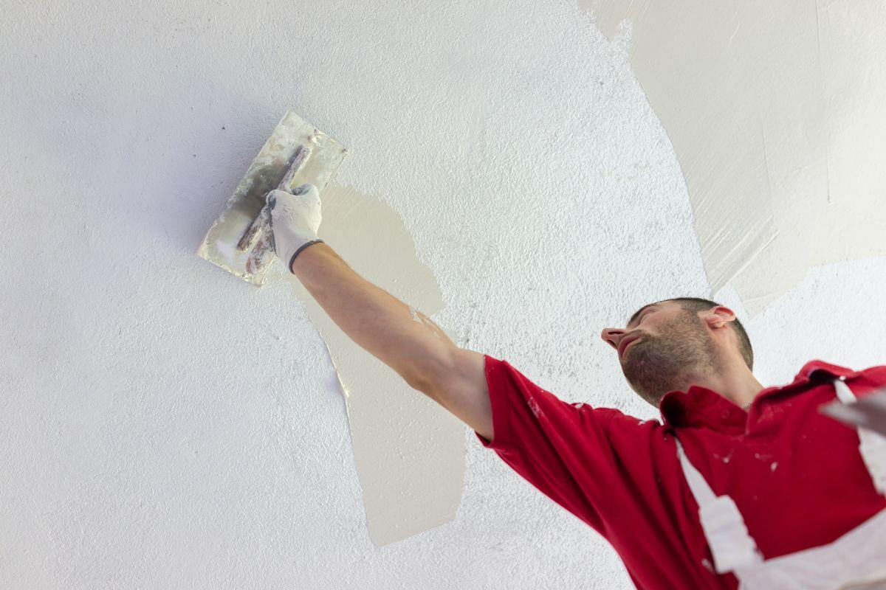

If you reside in plastering Hereford or surrounding areas, seeking local expertise can be advantageous as they are familiar with regional preferences and conditions.On the other hand, rendering is used for exterior surfaces, providing a protective and decorative layer to buildings. The render mix is generally composed of cement, sand, and lime, making it more robust and weather-resistant than plaster. This makes it ideal for withstanding the elements and improving the exterior appearance of a property. Engaging with professional plasterers Kidderminster can guarantee that your rendering job is done to the highest standards, protecting your home while enhancing its curb appeal.One of the key differences between plastering and rendering lies in their composition and application techniques. Plaster is applied in thinner layers and requires a smooth, even finish. In contrast, render is applied in thicker layers and can be finished in various textures, from smooth to rough, depending on the desired look. A knowledgeable plasterer Dudley can help you achieve the precise finish you need, whether it's for interior plastering or exterior rendering. Understanding these differences ensures you choose the right method for your project.

The benefits of professional plastering and rendering are numerous. Proper plastering provides a clean, even surface that can significantly improve the interior ambiance of your home. It also adds an extra layer of insulation, helping to maintain indoor temperatures. Rendering, meanwhile, protects exterior walls from moisture, cracks, and other environmental damage. It also adds an additional layer of insulation, improving energy efficiency. For those in plastering Hereford, consulting with a plasterer Hereford can provide insights into the best practices and materials suited to local climate conditions.In conclusion, deciding between plastering and rendering depends on whether you are working on interior or exterior surfaces and your specific project requirements. Understanding the distinct purposes and benefits of each method is crucial in making an informed decision. If you're in need of expert advice, reaching out to plasterers Kidderminster or a plasterer Dudley can provide the professional guidance necessary for achieving high-quality results. This knowledge ensures that your investment in home improvement is well-placed, resulting in durable and aesthetically pleasing finishes both inside and out.