**A Summary Of Art Book**

Introducing kids to art at an early age can ignite their creativity and imagination, providing them with a foundation for lifelong appreciation and expression. Art books designed specifically for young artists can be a wonderful tool in this journey. These books offer guidance, inspiration, and hands-on activities that make learning about art fun and engaging. By exposing children to various artistic styles and techniques through carefully curated art books, parents and educators can nurture their creative talents and encourage a deeper understanding of the visual arts. One of the essential types of art books for young artists is those that focus on basic drawing and painting skills. These books often come with step-by-step instructions, making it easy for kids to follow along and create their own masterpieces. Books like "Drawing for Kids" or "Painting with Watercolors for Young Artists" are excellent examples. They not only teach fundamental techniques but also provide plenty of space for children to practice and experiment. Such artist books can help build confidence in their abilities and foster a love for creating art. Browse the following website, if you're looking for additional information concerning [art book](https://www.booksaboutart.co.uk/).

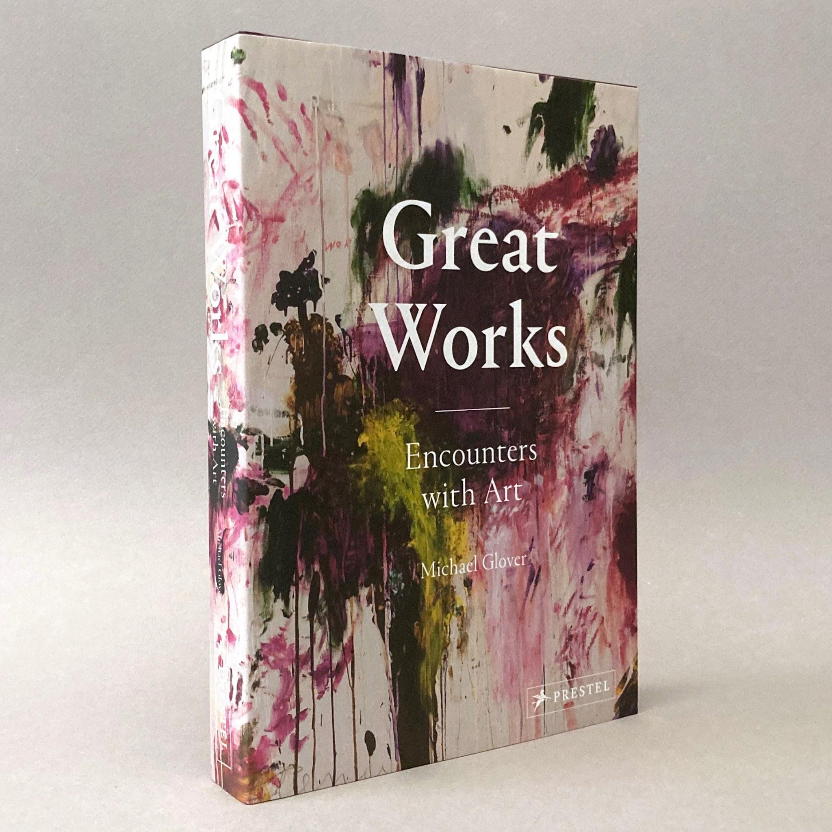

In addition to instructional art books, those that explore the lives and works of famous artists can be incredibly inspiring for young readers. Biographies of artists like Van Gogh, Picasso, and Frida Kahlo, tailored for a younger audience, can open up a world of possibilities. These artist books highlight the unique styles and contributions of each artist, showing children that there are many ways to express oneself through art. Books like "The Noisy Paint Box" about Kandinsky or "Frida Kahlo and Her Animalitos" are perfect examples that blend storytelling with art education. Interactive art books that combine reading with creative activities can also be highly beneficial. Books like "Art Lab for Kids" or "The Usborne Complete Book of Art Ideas" offer a variety of projects that encourage children to try different mediums and techniques. These artist books are packed with ideas that can keep young artists engaged and excited about art. They often include tips on using everyday materials to create unique works, making art accessible and fun for all children, regardless of their skill level or resources. Moreover, it's important to include art books that celebrate diversity and different cultures in a child's artistic education.

Books that showcase art from various parts of the world or those that highlight the works of artists from diverse backgrounds can broaden a child's perspective. Titles like "Children Just Like Me: A Celebration of Children Around the World" and "My Art Book of Friendship" help children see the universal language of art and its ability to connect people across cultures. These artist books emphasize that art is not just a skill but a way to understand and appreciate the world around us. In conclusion, art books play a crucial role in introducing kids to the world of art. From instructional guides and biographies to interactive projects and culturally diverse content, these books offer a wealth of knowledge and inspiration. By providing children with access to a variety of artist books, parents and educators can nurture their creativity, encourage self-expression, and instill a lifelong appreciation for the arts. Investing in these resources can have a lasting impact on a child's development, helping them grow into well-rounded and imaginative individuals.