**A Look At Waste Removal Services**

Managing waste responsibly is crucial for maintaining a clean and healthy environment. One of the significant waste categories is garden waste, which includes grass clippings, branches, leaves, and other organic materials. There are eco-friendly ways to manage garden waste, which can benefit both your garden and the environment. In this article, we'll explore five effective strategies to handle garden waste efficiently, focusing on Garden Waste Collection Bristol and the benefits of garden waste removal. Composting is one of the most effective eco-friendly ways to manage garden waste. It involves decomposing organic matter into nutrient-rich compost, which can be used to enrich your garden soil. By composting, you can reduce the amount of waste that ends up in landfills and create a sustainable cycle of nutrients for your garden. In Garden Waste Collection Bristol, there are services that provide compost bins and guidance on how to compost effectively. This method not only helps manage waste but also enhances the growth and health of your plants. Another excellent method for managing garden waste is mulching. Are you hunting for [bristol waste removal](https://solscapewaste.co.uk/)? Go to the earlier mentioned website.

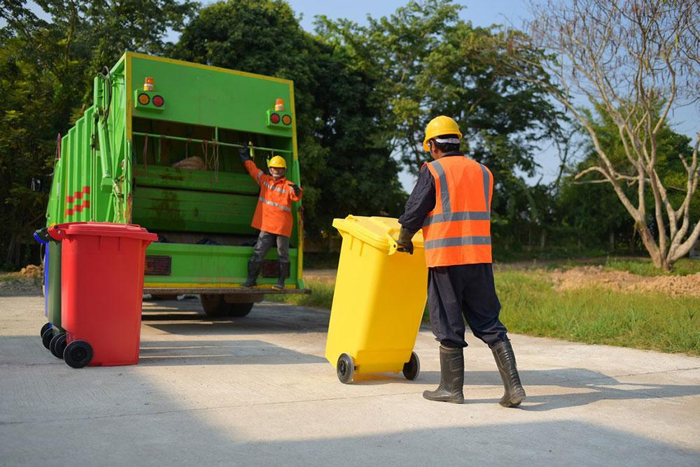

Mulch is a layer of material applied to the surface of the soil, which helps retain moisture, suppress weeds, and improve soil health. You can create mulch from leaves, grass clippings, and small branches. By doing this, you utilize the waste generated in your garden and contribute to its sustainability. In Bristol, garden waste removal services often offer mulching options, ensuring that your garden waste is reused efficiently. This practice reduces the need for chemical fertilizers and promotes a healthier garden ecosystem. Hiring a professional garden waste removal service is another effective way to manage your garden waste. These services ensure that all your garden waste is collected and disposed of properly. Garden Waste Collection Bristol offers various services that cater to different garden sizes and types. By using these services, you can save time and effort while ensuring that your garden waste is handled in an environmentally friendly manner. Professional removal services often recycle or compost the collected waste, contributing to the overall sustainability of the community. Recycling garden waste is another eco-friendly way to manage garden waste.

Certain types of garden waste, such as wood and branches, can be recycled into wood chips or used for other purposes. Recycling reduces the amount of waste that ends up in landfills and promotes the reuse of materials. In Bristol, many garden waste removal services have partnerships with recycling centers, ensuring that recyclable garden waste is processed appropriately. By choosing to recycle, you help conserve natural resources and reduce your environmental footprint. Lastly, you can consider creating a garden waste management plan. This involves assessing the types and amounts of waste your garden produces and finding the best ways to manage them. A plan can include composting, mulching, professional removal services, and recycling. Garden Waste Collection Bristol can assist in developing a comprehensive waste management plan tailored to your garden's needs. By having a plan in place, you can ensure that your garden waste is managed efficiently and sustainably throughout the year. In conclusion, there are several eco-friendly ways to manage garden waste that can benefit your garden and the environment. Composting, mulching, hiring professional garden waste removal services, recycling, and creating a waste management plan are all effective strategies. In Bristol, there are numerous options for garden waste collection that cater to different needs and preferences. By adopting these methods, you can reduce your environmental impact, enhance your garden's health, and contribute to a cleaner and more sustainable community.