**A Glimpse At Sports Ground Hire**

When choosing the perfect venue, it's crucial to consider several key factors, regardless of whether you're planning a wedding, sports event, or another type of gathering. The right venue can set the tone for your entire event, so it's important to take your time and weigh your options carefully. Whether you're looking for a wedding venue Watford or venue hire Hertfordshire, there are specific elements to keep in mind to ensure your event is a success. Firstly, location is paramount. When considering wedding venues near Watford, you want to ensure that the venue is easily accessible for your guests. This is also true for sports ground hire or any sports club venue hire. The venue should be conveniently located with good transport links and ample parking. For those looking at a venue for sports, proximity to public transportation and major highways can make a significant difference in attendance and overall satisfaction. Additionally, if you're considering a more casual event, you might explore options like a Bushey pub or pubs in Bushey Herts for their friendly atmosphere and convenient location. Secondly, the facilities and amenities available at the venue are critical. For a wedding, you might prioritize a beautiful setting, excellent catering options, and ample space for dancing and dining. If you are hunting for additional details on [sports ground hire](https://www.metropolitanbushey.co.uk/sports-facilities/), explore the mentioned above website.

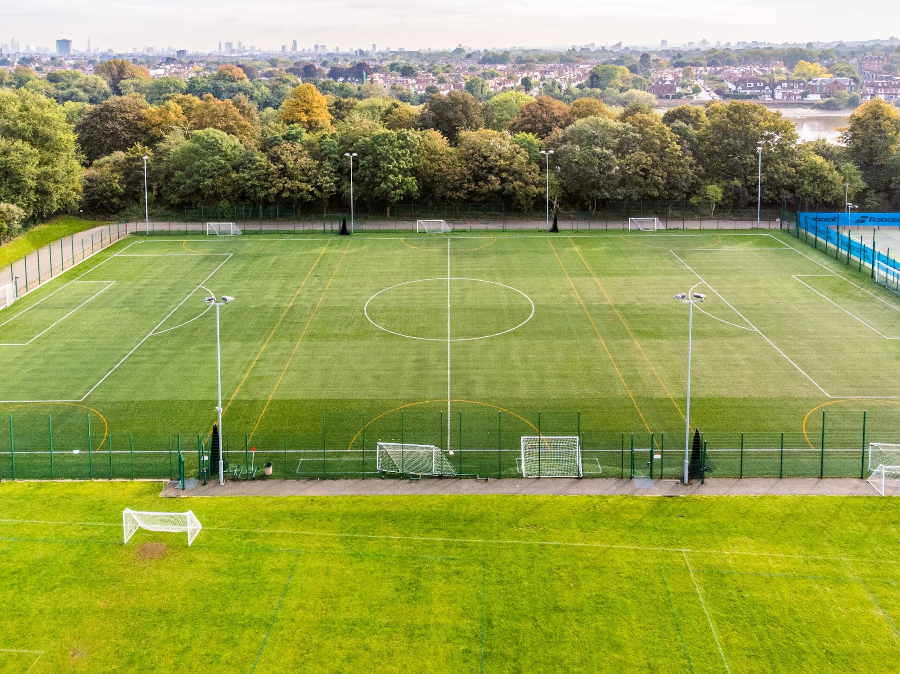

For a wedding, you might prioritize a beautiful setting, excellent catering options, and ample space for dancing and dining. If you're looking at sports ground hire, ensure the venue has the necessary equipment, locker rooms, and seating for spectators. Similarly, sports club venue hire should include facilities like meeting rooms, audiovisual equipment, and comfortable seating areas. For any event, check if the venue offers additional services such as on-site coordination, security, and technical support, which can greatly ease the planning process. Thirdly, the capacity and layout of the venue must align with your event needs. When researching wedding venues Watford or wedding venues near Watford, confirm that the venue can comfortably accommodate your guest list. For sports events, the layout should allow for clear visibility of the action and safe, unobstructed movement. Pubs near Bushey or a Bushey pub might offer a unique and intimate setting for smaller gatherings or after-event parties. Always visit the venue in person, if possible, to get a feel for the space and ensure it matches your vision. Fourthly, consider the cost and value for money. Whether it's venue hire Hertfordshire or a wedding venue Watford, it’s essential to stay within your budget without compromising on the quality of your event.

Ask for a detailed breakdown of costs and understand what is included in the price. Look for packages or discounts that might be available, especially if you're booking multiple services through the same venue. For sports events, consider the cost of additional requirements like referees, equipment, and staff. For weddings, factor in the cost of decorations, entertainment, and any additional services offered by the venue. Lastly, reviews and recommendations play a crucial role in choosing the perfect venue. Reading testimonials from previous clients can provide insights into the reliability and quality of the venue’s services. Ask for references and speak to other event organizers who have used the venue. Positive feedback about the venue's staff, amenities, and overall experience can give you confidence in your decision. Whether it's a sports club venue hire or a wedding venue near Watford, knowing others had a successful event there can reassure you of your choice. In conclusion, selecting the right venue involves careful consideration of location, facilities, capacity, cost, and reputation. By keeping these factors in mind, you can find the perfect setting for your event, ensuring a memorable and enjoyable experience for all attendees. Whether you're planning a wedding, a sports event, or a casual gathering at one of the pubs near Bushey, the ideal venue will help bring your vision to life and create lasting memories.