**A Few Things About Decorative Antique Furniture**

Discovering the charm of Swedish antique painted furniture is like stepping into a world of timeless elegance and refined craftsmanship. This style, known for its simplicity and muted colors, originated in the 18th century and has remained a favorite among collectors and interior designers. The soft, distressed finishes and subtle decorations bring a sense of history and sophistication to any space. If you're looking for decorative antique furniture that adds both beauty and character to your home, Swedish painted pieces offer a unique and stylish option. One of the defining features of Swedish antique painted furniture is its use of light colors and natural materials. Typically painted in shades of white, gray, and pastel hues, these pieces create a bright and airy atmosphere, perfect for modern interiors seeking a touch of vintage charm. The paint is often delicately distressed, highlighting the craftsmanship and giving the furniture a well-loved, timeless appearance. If you're searching for additional details on [decorative antique furniture](https://www.louisehalldecorative.com/furniture), click on the earlier mentioned website.

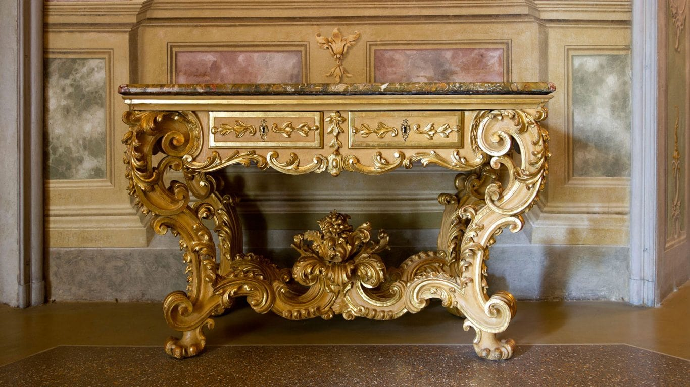

This style complements a wide range of décor themes, from minimalist to rustic, making it a versatile choice for enhancing your home’s aesthetic. The appeal of decorative antique furniture lies in its ability to tell a story. Each piece of Swedish antique painted furniture carries with it a history and a sense of place. For instance, a painted Swedish armoire with intricate floral motifs can become a focal point in a bedroom, while a set of Gustavian dining chairs adds elegance to a dining room. These antiques are not just functional; they are works of art that bring a sense of heritage and sophistication to any space. Collectors and decorators alike value these pieces for their unique beauty and craftsmanship. When searching for antiques near Oxford, there are several reputable dealers who specialize in Swedish painted furniture. These experts can provide insights into the provenance and historical context of each piece, ensuring that you find genuine items that will enhance your collection. Shopping locally also allows you to see the furniture in person, appreciating the fine details and quality of the craftsmanship.

Whether you're looking for a specific item or just browsing for inspiration, the antique shops around Oxford offer a wealth of options. In addition to their aesthetic appeal, Swedish antique painted furniture pieces are also highly functional. Many of these antiques were designed with practicality in mind, featuring ample storage and sturdy construction. A painted Swedish cabinet, for example, can serve as a stylish storage solution in a kitchen or living room, while a Gustavian chest of drawers adds both beauty and functionality to a bedroom. The durability and timeless design of these pieces ensure that they can be enjoyed for generations, making them a valuable investment.In conclusion, Swedish antique painted furniture offers a perfect blend of beauty, history, and functionality. These pieces, with their light colors and distressed finishes, add a touch of elegance and sophistication to any home. As you explore decorative antique furniture, consider the unique charm and craftsmanship of Swedish painted items. When searching for antiques near Oxford, take advantage of local dealers who can provide authentic and high-quality pieces. By incorporating these antiques into your home, you not only enhance its aesthetic appeal but also connect with a rich heritage of design and craftsmanship.