**A Few Facts About Elopement Wedding**

The traditional image of a sprawling wedding with hundreds of guests is slowly evolving. Modern couples are increasingly embracing the concept of elopement weddings. These intimate ceremonies, often held in breathtaking locations like Scotland, offer a unique and adventurous alternative, allowing couples to celebrate their love on their own terms. Understanding the reasons behind the rise of elopement weddings and the allure of Scotland as a destination is crucial for couples seeking a truly unforgettable experience. For many couples, the pressure of adhering to elaborate wedding traditions and expectations can feel overwhelming. Elopement weddings offer an escape from these constraints. Couples can personalize their ceremony to reflect their unique personalities and preferences. Whether exchanging vows on a secluded beach or atop a scenic mountain peak in Scotland, elopements allow for a more intimate and meaningful celebration of love. Elopements remove the distractions often associated with large weddings. Click on the following website, if you are seeking for more details about [elopement wedding](https://theelopementcompany.com/).

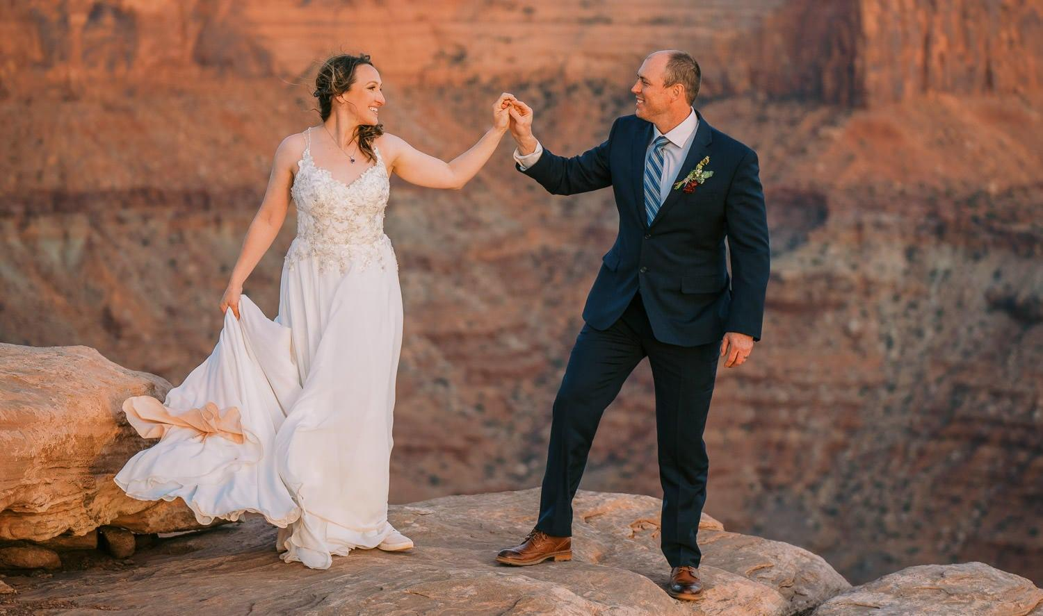

Couples can focus solely on their commitment to each other, creating lasting memories without the stress of managing guest logistics or entertainment. This intense focus on the relationship fosters a deeper connection and allows for a truly heartfelt ceremony.For adventurous couples, elopement weddings offer the opportunity to combine their special day with an unforgettable trip. Scotland elopements, for example, allow couples to explore the country's stunning landscapes and charming villages, creating a unique and personalized wedding adventure. Imagine exchanging vows amidst ancient castles or breathtaking coastlines, forever etching these experiences into your love story. Elopement weddings present an appealing option for couples seeking both intimacy and financial prudence. Compared to traditional ceremonies, elopements are often notably more affordable. The absence of expenses associated with large venues, catering services, and extensive guest arrangements translates to significant cost savings. Couples can redirect these funds towards creating unforgettable experiences, whether through splurging on a luxurious honeymoon or enhancing the elopement itself with personalized touches.

This financial flexibility allows couples to prioritize what truly matters to them, whether it's exploring exotic destinations, indulging in fine dining experiences, or adding special elements to their elopement ceremony. Although elopements are often perceived as simpler than traditional weddings, some degree of planning is still essential. For Scotland wedding elopements, couples must navigate legal requirements and explore potential vendors offering specialized elopement packages. This planning phase provides an opportunity for couples to work together closely, crafting a celebration that reflects their individuality and love story. While the process may involve logistical considerations, such as securing permits or arranging transportation, it also allows for creativity and personalization. Ultimately, elopement weddings are about celebrating love on your own terms. By opting for an elopement, couples prioritize the essence of their relationship – their commitment to each other. Whether exchanging vows in the majesty of Scotland or another cherished location, elopements offer a unique and intimate way to begin a lifetime together.