**User Guide On Commercial Fire Doors**

It is the responsibility of employers to ensure their employees feel comfortable and safe while working on the premises. This is the reason businesses prefer to install the proper safety equipment in their workplace to protect their work equipment, workers and machines. While safety installation equipment can avoid accidents and mishaps; disasters like fire and earthquakes are non-avoidable. This is why businesses are collaborating with fireproofing companies to ensure their building is safe in case of fire. The biggest problem companies face while dealing with fire is employees getting panicked and making rash decisions. While all buildings have fire exits, you need to be prepared to deal with fires in advance. Fireproofing your work premises has several benefits. If you're looking to learn more about [commercial fire doors](https://www.nationalfireltd.co.uk/fire-door-installers-uk/), take a look at earlier mentioned website.

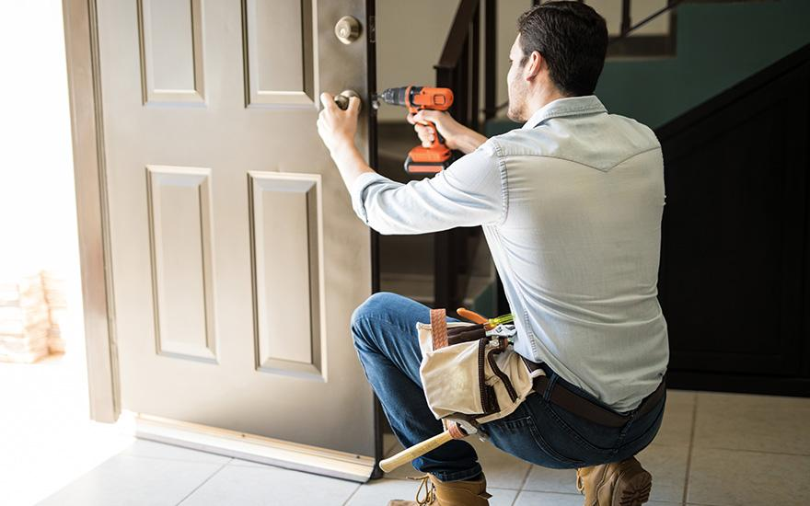

The top reason for the popularity of fire management services is they help corporations protect their infrastructure and equipment. Fireproofing companies offer their services after and before a structure is made. Fires are known to cripple a business, and many companies are in constant fear of short circuits. Enterprises often cannot deal with losses caused by fire. Companies need to fireproof their offices if they do not want to opt for expensive after-repairs or be involved in legal battles. With equipment like fire ceilings and barriers, corporations can lessen their damage and ensure their work operations do not get damaged. Some states have strict laws against businesses which are not equipped to deal with fires. You might land in legal trouble or have to pay fines and penalties if your workplace is not fireproof. Using fire safety equipment like fire resistant doors and fireproof partitions can minimise the damage. This enables businesses to keep their essential work equipment like machines, computers, printers and energy storage services safe from fires.

Many employees are worried about their safety and wish to work at fireproof offices. Enlisting your company as fire-protected can help you get more investors for your business. Several passive fire protection contractors work in the best client interests and help companies minimise their fire damage. Fire barriers can protect your warehouse and high-tech work areas. Another issue companies face while dealing with fires is excessive smoke. However, a fire barrier and fire-resistant door can prevent harmful smoke from spreading and protect their workers. Many fire prevention companies suggest using 1 and 2-hour fire-rated ceilings to protect your building. These ceilings prevent the complete roof from collapsing in case of fires. With extended time companies can empty their workplace and move their employees to a safe place. The fireproofing process is easy and does not take too much time. Therefore, corporations must contact a reliable fire protection firm to install fireproof ceilings and barriers in their workplace.