Precise Analysis On The Creative Printed Wall Graphics

When selecting the right hoarding graphic panel service to promote your business, it's essential to consider several key factors that can impact the effectiveness and visual appeal of your hoarding graphics. First and foremost, prioritize expertise and experience in creating compelling hoarding graphics. Look for a service provider that specializes in hoarding graphics and has a proven track record of delivering visually striking and engaging designs. Experienced professionals understand the unique requirements of printed hoarding panels and can create designs that effectively promote your business and attract attention. Furthermore, consider the range of services offered by the hoarding graphic panel service. Besides designing and printing hoarding graphics, do they provide installation services? A comprehensive service that handles the entire process from design to installation ensures a seamless and hassle-free experience for promoting your business through hoarding panels. If you're searching for additional details on creative printed wall graphics, look at the mentioned above website.

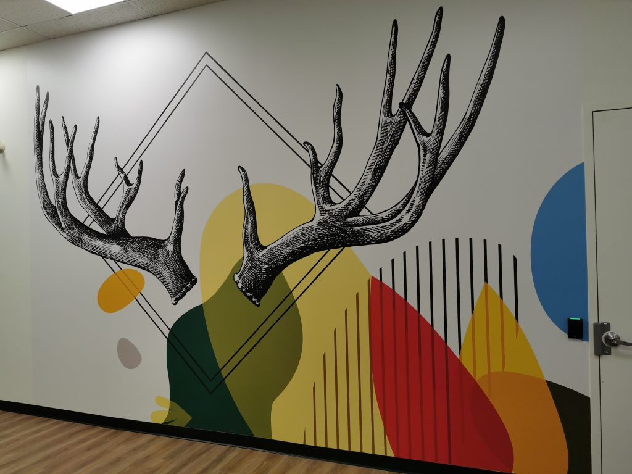

Additionally, inquire about customization options and flexibility in design. Can the service provider tailor hoarding graphics to align with your branding, messaging, and marketing objectives? Choose a service that offers customization options to create unique and impactful hoarding designs that reflect your business identity. Another crucial aspect to consider is the quality of materials used for printed hoarding panels. High-quality materials ensure durability, weather resistance, and vibrant colors that withstand outdoor conditions. Ask about the printing technology and materials used by the service provider to ensure that your hoarding graphics maintain their visual appeal and effectiveness throughout the duration of the hoarding campaign. Additionally, inquire about eco-friendly printing options if sustainability is a priority for your business. When evaluating hoarding graphic panel services, review their portfolio of past projects and client testimonials. This provides insights into the quality of their work, design capabilities, and customer satisfaction levels. Look for examples of hoarding graphics they have created for businesses similar to yours and assess the creativity, clarity, and impact of their designs.

Positive feedback and successful case studies indicate a reliable and effective hoarding graphic panel service that can elevate your business promotion efforts. Consider the level of customer support and communication offered by the hoarding graphic panel service. Clear and open communication is essential throughout the design, printing, and installation process. Ensure that the service provider listens to your requirements, provides timely updates and revisions, and addresses any concerns or questions promptly. A collaborative and communicative approach fosters a positive working relationship and ensures that your vision for hoarding graphics is translated effectively into impactful designs. In summary, choosing the right hoarding graphic panel service to promote your business involves considering expertise in hoarding graphics, customization options, range of services, quality of materials, portfolio and testimonials, and level of customer support. By partnering with a service provider that excels in creating visually compelling printed hoarding panels, offers customization, uses high-quality materials, and provides excellent customer service, you can effectively promote your business and capture attention through impactful hoarding graphics.

