**In-Depth Analysis On The Shower Tray Repair**

Maintaining a pristine bathroom is a priority for homeowners seeking both functionality and aesthetic appeal. The journey towards achieving this goal involves a comprehensive approach, considering various aspects such as sink crack repair, bathroom sink crack repair, ceramic sink crack repair, shower tray repair, and bathtub rust repair. Shower repairs necessitate a nuanced strategy, taking into account the material composition of the shower base, historical cleaning practices, and future maintenance considerations. When addressing bath repairs, homeowners unlock significant benefits that enhance the longevity and visual appeal of their bathing space. Central to bath repair services is the remediation of issues like bath enamel repair, bath chip repair, and shower tray repair. These services are tailored to combat the wear and tear that bathrooms inevitably endure over time, ensuring that functionality and aesthetics are preserved. Make a search on the following site, if you are seeking for additional information about [shower tray repair london](https://repairmanuk.co.uk/shower-tray-crack-repair/).

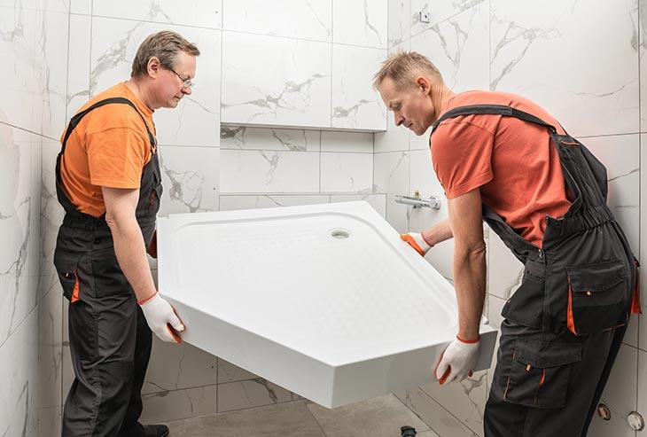

The material composition of the shower base, including porcelain sink repair, plays a pivotal role in delivering a lasting solution to chips, cracks, or rust in bathroom fixtures. Bath enamel repair is a specialized service focused on restoring the protective coating of bathtubs, extending their lifespan and maintaining a smooth, easy to clean surface. Similarly, bath chip repair addresses unsightly dings and nicks that accumulate over the years, diminishing the visual appeal of the bath and potentially harboring dirt and grime. Opting for bath chip repair services ensures that the bathtub remains a focal point in the bathroom, free from distracting imperfections. Shower tray repair is equally critical, especially in cases of shower tray chip repair or shower tray crack repair. The constant exposure to water, cleaning agents, and foot traffic makes the shower base susceptible to damage. Timely repairs can prevent these issues from escalating, preserving the integrity of the shower space and minimizing potential hazards. Porcelain sink repair is another essential service contributing to the overall rejuvenation of the bathroom. A chipped or cracked sink not only detracts from the visual appeal but can also lead to water damage if left unattended.

Seeking professional assistance for porcelain sink repair ensures that the damage is comprehensively addressed, leaving homeowners with a gleaming and functional fixture. Furthermore, bath repair services offer the added benefit of addressing concerns related to household health. Lingering issues like rust can compromise the hygiene of the bathroom environment. Bathtub rust repair becomes essential in mitigating this concern, preventing the spread of rust and maintaining a clean and safe bathing space. The multifaceted benefits of bath repair services extend beyond mere aesthetics. By addressing specific issues such as bath enamel repair, bath chip repair, shower tray repair, shower tray chip repair, shower tray crack repair, porcelain sink repair, and bathtub rust repair, these services contribute to the overall well being of the bathroom. Homeowners seeking to maintain a functional and aesthetically pleasing bathing space should consider the nuanced approach offered by bath repair services, ensuring a bathroom that stands the test of time.