Important Things About Waste Management

Efficient waste management is vital for hardware businesses, particularly those dealing with scrap metal and waste materials. Choosing a professional waste collection service offers numerous benefits that can significantly impact the overall operations and success of a hardware business. One of the key reasons why partnering with a waste collection service is important is the maintenance of a clean and safe working environment. Hardware businesses often generate substantial amounts of waste, including scrap metal, packaging materials, and other debris. Failure to manage this waste properly can lead to cluttered and hazardous workspaces, posing safety risks to employees and customers alike. By enlisting a waste collection service, businesses ensure that waste is promptly and responsibly disposed of, keeping the premises clean, organized, and free from potential hazards. Moreover, proper waste management is essential for regulatory compliance and environmental sustainability. Scrap metal, in particular, requires specialized handling and disposal methods to minimize environmental impact and comply with regulations. Professional waste collection services are well-versed in environmentally friendly waste disposal practices, such as recycling and proper disposal of hazardous materials. Are you looking about waste removal bristol? Go to the earlier described site.

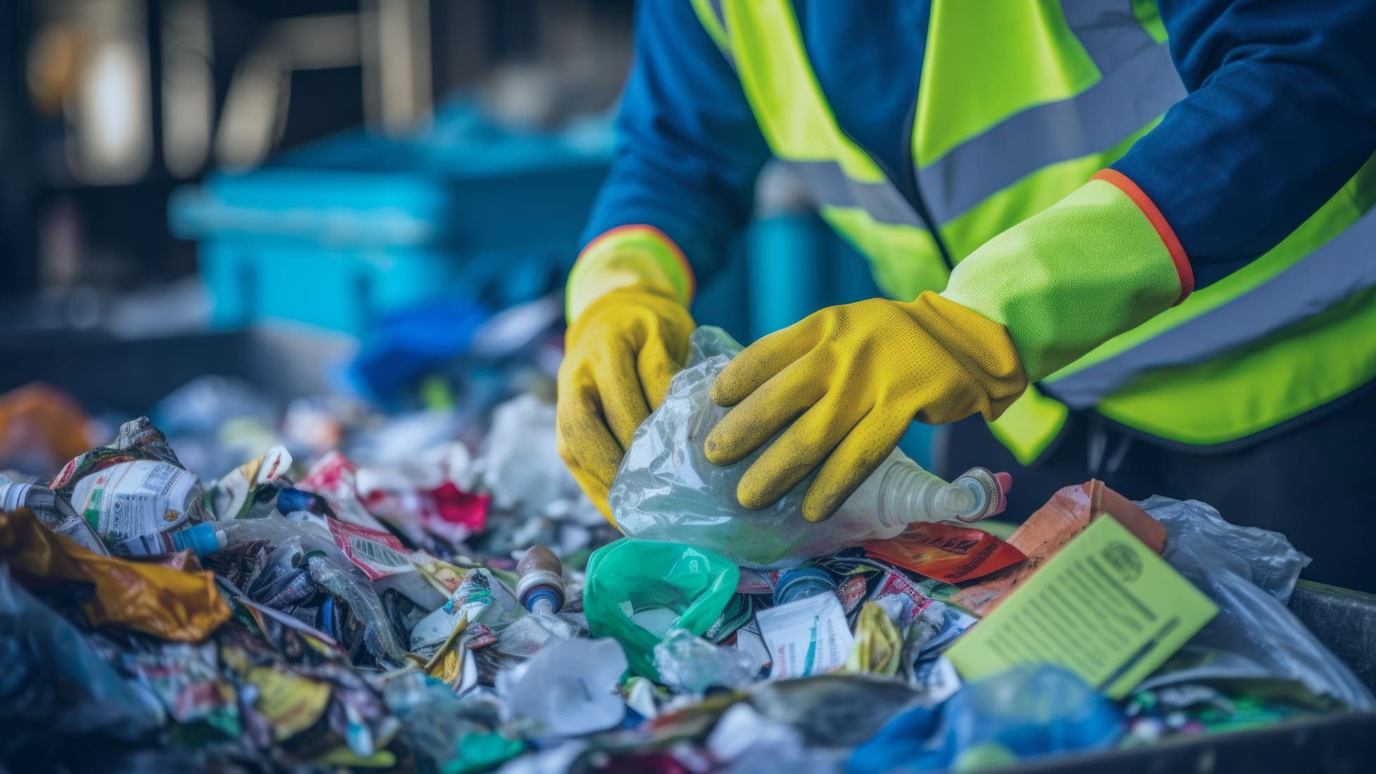

Partnering with such a service demonstrates a commitment to environmental responsibility and helps businesses adhere to legal requirements, avoiding potential fines or penalties. Additionally, efficient waste collection and removal contribute to cost savings for hardware businesses. Accumulated waste takes up valuable space, requires additional labor for cleanup, and may lead to fines for improper disposal. By streamlining the waste management process through a waste collection service, businesses reduce labor costs associated with waste handling and minimize the risk of legal repercussions. This cost-effective approach allows businesses to allocate resources more efficiently and focus on core operations, ultimately improving productivity and profitability. Furthermore, partnering with a waste collection service offers convenience and flexibility. Businesses can schedule regular waste pickups based on their specific needs and volume of waste generation. This ensures that waste is removed in a timely manner, preventing buildup and maintaining a clutter-free environment. Waste collection services also provide containers or bins for efficient waste storage and collection, enhancing organization and workflow within the business premises. Another advantage of choosing a waste collection service is access to expertise and specialized equipment.

Waste collection professionals are trained in proper waste handling techniques, including segregation of recyclable materials and management of hazardous waste. They have the necessary equipment, such as trucks, containers, and tools, to handle different types of waste safely and efficiently. This expertise and equipment ensure that waste is managed responsibly, minimizing risks and maximizing resource recovery through recycling and reuse. Moreover, partnering with a reputable waste collection service enhances the reputation and image of a hardware business. Demonstrating a commitment to proper waste disposal and environmental sustainability can attract environmentally conscious customers and stakeholders. It also sets the business apart from competitors and positions it as a responsible corporate citizen contributing to a healthier environment and community. In conclusion, the benefits of choosing a waste collection service for hardware businesses are extensive and impactful. From maintaining a clean and safe work environment to achieving regulatory compliance, reducing costs, and enhancing sustainability practices, the advantages of professional waste management services are clear. By investing in efficient waste management solutions, hardware businesses can improve overall operations, minimize risks, and make a positive contribution to the environment and society.

