**Important Things About Personalised Football Gifts**

With the festival around the corner, people wish to find personalised gifts and wall decor items for their loved ones and friends. If you put your heart and soul into gifting and want to get your hands on exclusive products, you can opt for online gift websites. Football is a popular sport, and every household has a football fan. Thus, you can add a loving touch to the gifts with a personalised football gift. There are several football gifting websites where you can find amazing stuff that will fit the personality of your loved ones. The biggest benefit of personalised football gifts is the effort that goes in planning and customising them. You can do everything in minutes from finding a gift according to a specific age group to making purchases instantly. Individuals can add a personal touch to their gifting process and purchase tokens of affection for football enthusiasts online. In this manner, they can convey how much they love the person they are gifting the item to and allow them to have something to cherish. Check out the below mentioned website, if you're searching for more details on [personalised football gifts](https://www.footballgifts.co.uk/).

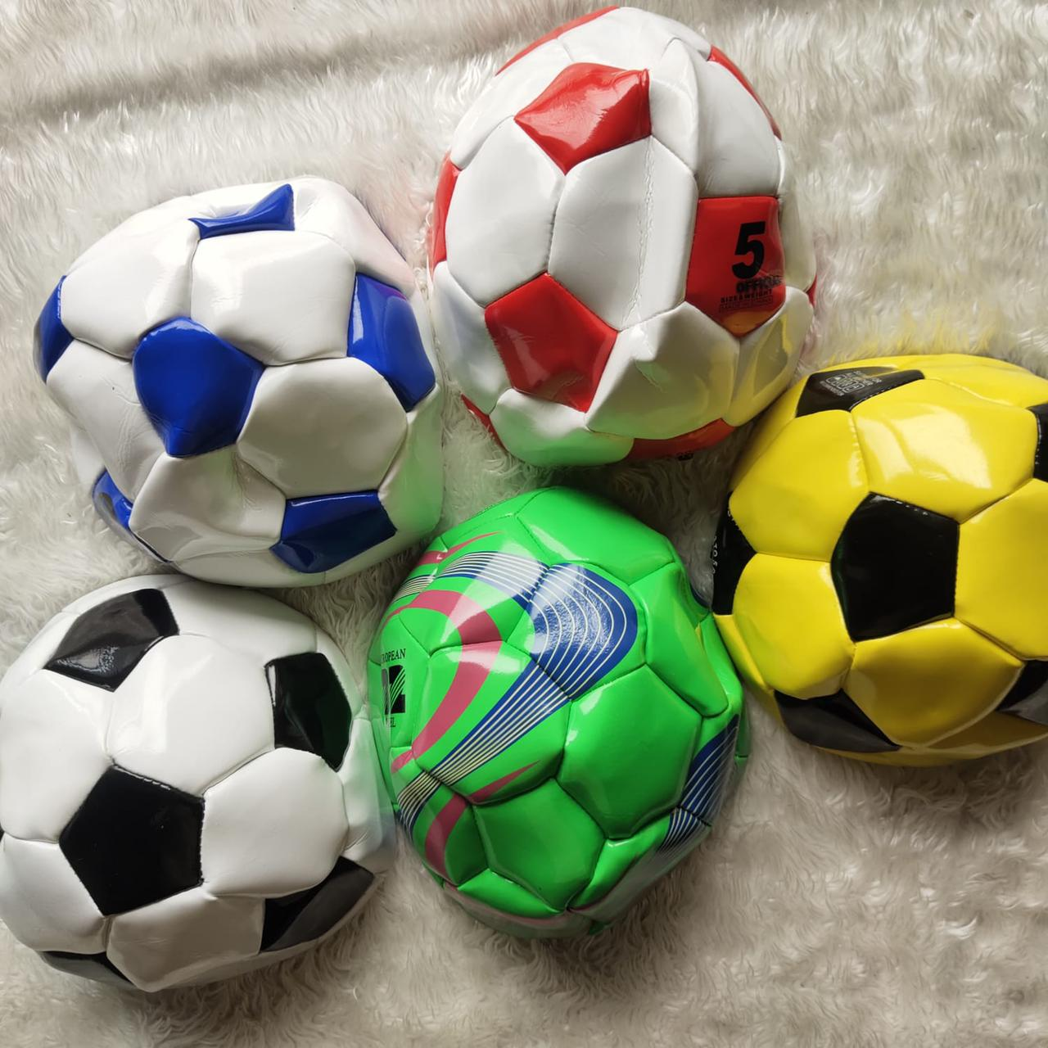

Football t-shirts and wall hangings have sentimental value and a special place in people's hearts. An added benefit of personalised football gifts is that they are unforgettable and enable individuals to cherish them for life. Users can customise the gift according to their friend or loved one’s personality and ensure they love it. It can be a customised t-shirt for your five-year-old nephew or a personalised team mug for your boss. Football gifts make excellent corporate and personal gifting options. Some parents wish for their children to be associated with sports from early childhood. This is why they enrol them in kids’ football academies to help them learn about the sport. Additionally, parents and guardians can opt for personalised football team shirts to include the desire to learn more about football in their young ones. They can discover child-safe gifts and ensure their children become sports enthusiasts. Kids love having personalised football shirts they play with; they love to flaunt them to their friends.

Online football gift websites have something for everyone. You can filter your searches and find what you want in minutes. You can personalise the gifts however you want without worrying about extra charges. You can search for online gift stores if you wish to get your hands on novelty football gifts. They have unique products available and help people create memories to last a lifetime. People can have the gifts delivered directly to their loved ones with a special message or get them delivered to their homes. Online football gift stores customise the delivery to fit their busy schedules. Personalised football gifts are suitable for all occasions and make a memorable gift for your loved ones. E-gift stores have a wide variety of choices available for football fans. Individuals can choose among several custom-name football shirts and socks on their website. This helps avoid confusion, and people can shop for all their friends and family in one place.