**Closer Look On Lifeboat Maintenance Services**

Lifeboat maintenance services are crucial for ensuring the safety and functionality of life-saving equipment aboard ships. Regular lifeboat inspections are essential to identify potential issues and prevent malfunctions during emergencies. These services encompass a range of features, including thorough checks of lifeboat systems, mechanical components, and safety devices. Firstly, lifeboat maintenance services involve routine lifeboat inspections to assess the condition of lifeboats and associated equipment. This includes examining the hull integrity, propulsion systems, launching mechanisms, and emergency communication devices. By conducting these inspections regularly, potential defects or failures can be detected early, allowing for timely repairs or replacements. Secondly, regular lifeboat inspections are crucial for ensuring compliance with safety regulations and standards set by maritime authorities. Ships must adhere to specific guidelines regarding the maintenance and inspection of lifeboats to ensure their readiness for use in emergencies. Failure to comply with these regulations can result in penalties and, more importantly, jeopardize the safety of crew members and passengers. If you are seeking to learn more about [lifeboat maintenance services](https://www.survivalsystemsinternational.com/uk/maintenance-inspection/), take a look at above site.

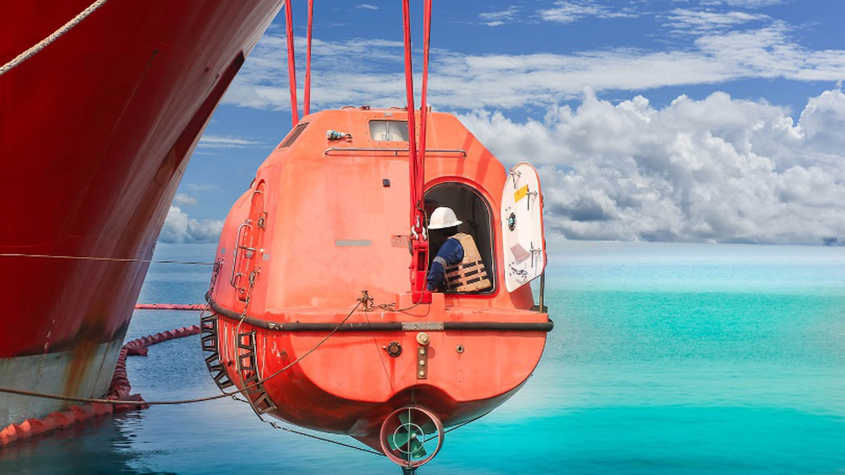

Thirdly, lifeboat maintenance services encompass the testing and calibration of essential life-saving equipment such as life rafts, survival suits, and distress signals. These checks ensure that these devices are operational and effective when needed during emergencies at sea. Properly maintained and functional equipment can significantly increase the chances of survival in life-threatening situations. Lifeboat maintenance services go beyond just physical inspections and repairs; they encompass crucial training sessions for crew members. These sessions focus on teaching personnel the correct utilization of life-saving equipment and emergency protocols. Such training is indispensable as it ensures that the crew is not only aware of the equipment onboard but also proficient in its usage during critical situations. By being well-prepared and competent in lifeboat operations and rescue procedures, crew members can swiftly and effectively respond to emergencies, potentially saving lives and mitigating risks at sea. Therefore, including training as part of lifeboat maintenance services significantly enhances the overall safety and preparedness of maritime operations. Lifeboat maintenance services extend their scope to encompass comprehensive risk assessments and emergency response planning. These additional features are vital components that contribute significantly to enhancing safety measures onboard ships. Risk assessments conducted as part of lifeboat maintenance services involve a thorough examination of potential hazards related to lifeboat operations.

This includes assessing factors such as equipment functionality, environmental conditions, crew competency, and potential scenarios that could lead to emergencies. By identifying these risks proactively, strategies can be developed to mitigate them effectively. Emergency response planning is another crucial aspect of lifeboat maintenance services. This involves developing detailed protocols and procedures for responding to various emergency situations, such as fire incidents, flooding, or vessel distress. These plans outline the roles and responsibilities of crew members, communication protocols, evacuation procedures, and coordination with external emergency services. In conclusion, lifeboat maintenance services play a critical role in ensuring the safety and readiness of life-saving equipment on ships. Regular lifeboat inspections are essential for identifying and addressing potential issues early, ensuring compliance with safety regulations, testing and calibrating life-saving equipment, providing crew training, and enhancing emergency preparedness. Investing in comprehensive lifeboat maintenance services is key to saving lives and minimizing risks in maritime environments.