A Few Details About Tool Boxes

Gardeners rely on a variety of garden tools to maintain their outdoor spaces efficiently. One essential tool is the garden spade, which is used for digging and turning soil. It's helpful for planting, transplanting, and creating new garden beds. The spade's sharp, flat edge cuts through soil and roots effectively. To use it, position the spade vertically, step on the blade, and push it into the ground, then lever the soil upward. Another crucial garden tool is the hand trowel, ideal for small-scale digging, planting, and weeding tasks. Its compact size and narrow blade make it perfect for working in tight spaces or containers. To use a hand trowel, grip the handle firmly, insert the blade into the soil, and leverage it to lift soil or plants gently. For cutting tasks, gardeners rely on pruners or secateurs. These tools come in bypass or anvil styles, with bypass pruners being more versatile for precise cuts on live branches. Anvil pruners are better suited for deadwood and tough stems. To use pruners, position them around the branch or stem to be cut and squeeze the handles together firmly. Visit the below mentioned site, if you're searching for additional information regarding tool boxes.

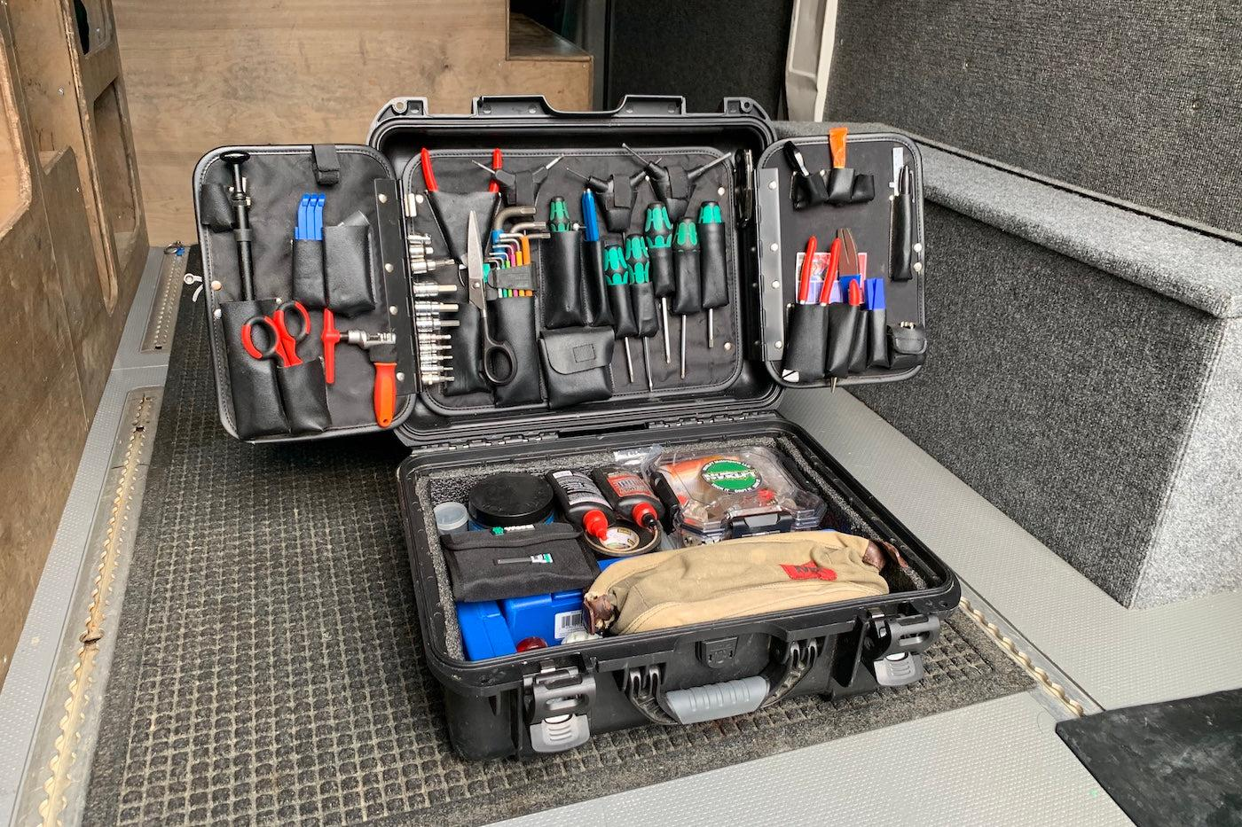

A garden rake is indispensable for leveling soil, removing debris, and spreading mulch or compost. Its sturdy tines can handle various tasks, from gathering leaves to smoothing out soil surfaces. To use a garden rake, hold the handle firmly and pull it towards you, using short strokes to gather debris or level the soil. Garden shears are essential for trimming hedges, shrubs, and small branches. They come in different sizes and styles, including straight-blade shears for precise cuts and serrated-blade shears for thicker branches. To use garden shears, position the blades around the branch to be cut and exert pressure evenly to achieve a clean cut. A watering can or hose is crucial for keeping plants hydrated, especially during dry periods. Choose a watering can with a narrow spout for precise watering of individual plants or a hose with an adjustable nozzle for larger areas. To use a watering can or hose, direct the water flow at the base of plants, avoiding foliage to prevent fungal diseases. Garden gloves are essential for protecting hands from cuts, blisters, and thorns while working in the garden.

Choose gloves made of durable materials like leather or synthetic blends for maximum protection. To use garden gloves, wear them snugly to ensure a secure grip on tools and prevent injuries. A garden fork is useful for aerating soil, breaking up clumps, and turning compost piles. Its sturdy tines can penetrate compacted soil easily. To use a garden fork, position it vertically and push it into the soil, then lever the handle backward to loosen and aerate the soil. A wheelbarrow or garden cart is indispensable for transporting heavy materials like soil, mulch, plants, or garden waste. Choose a wheelbarrow with sturdy handles and a balanced design for easy maneuverability. To use a wheelbarrow, load materials into the tray, grip the handles firmly, and push or pull it to the desired location. Finally, a pruning saw is essential for cutting larger branches or tree limbs. Choose a pruning saw with a sharp, durable blade and a comfortable handle for efficient cutting. To use a pruning saw, position the blade against the branch to be cut and use long, steady strokes to saw through the wood. In conclusion, gardeners benefit from having a diverse range of garden tools to tackle various tasks effectively. From digging and planting to pruning and watering, the right garden tools can make gardening more enjoyable and productive.

