**A Summary Of Leave Management Software**

At the heart of any dependable leave management system lies the cornerstone of an efficient and versatile online staff leave planner. This crucial component forms the linchpin for effortless tracking and administration of employee leave records, ensuring a smooth and hassle free process. The online staff leave planner stands as the keystone of any proficient leave management system. This dynamic tool streamlines the intricate task of tracking and overseeing employee leave records. With its user-friendly interface, the online leave planner empowers organizations to effortlessly manage their staff's holiday schedules. Leave management software, often integrated with an online leave management system, serves as a powerful tool for organizations. It offers a comprehensive solution for tracking, planning, and managing employee holidays. This sophisticated software is designed to simplify the holiday tracking process while minimizing the potential for errors. If you're searching to learn more about [leave management software](https://www.leavewizard.com/), click on the mentioned above site.

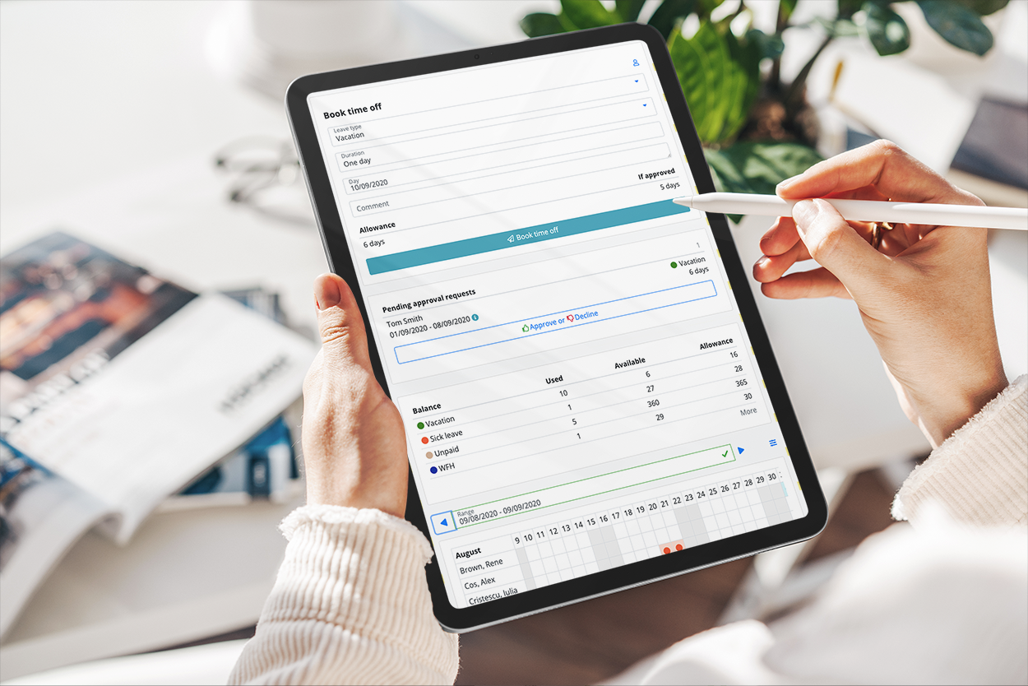

One of the pivotal features of a leave management system is the holiday tracker. This indispensable tool provides a convenient means to monitor employee holiday schedules and ensure that the workforce's time off is adequately accounted for. The holiday tracker aids in efficient workforce planning, helping organizations to allocate resources optimally. A staff holiday planner, intricately linked with the online leave management system, offers a holistic approach to employee holiday scheduling. This tool enhances an organization's capacity to manage and organize staff holidays efficiently. By optimizing the allocation of leaves, the staff holiday planner ensures that the workforce's time off aligns with business demands. The employee holiday planner is another integral component within the leave management system. It empowers employees to plan their holidays proactively, fostering a sense of transparency and control over their time off. This encourages employees to take leave when they need it while ensuring that their absence does not disrupt operations.

The online staff leave planner, leave management software, and holiday tracker collectively ensure that organizations can maintain a balanced workforce while allowing employees the freedom to take time off as needed. This harmonious synergy enables businesses to enhance employee satisfaction, reduce leave related conflicts, and maintain operational efficiency. The staff holiday planner plays a pivotal role in fostering a conducive work environment by facilitating the equitable allocation of holidays. It ensures that employees can plan their time off effectively and enjoy a healthy work life balance. In turn, this contributes to improved employee morale and job satisfaction. A robust leave management system, anchored by an online staff leave planner and supported by leave management software, holiday tracker, staff holiday planner, and employee holiday planner, is indispensable for modern organizations. It provides a seamless solution for managing employee leave records, optimizing workforce planning, and enhancing employee satisfaction. By adopting such a comprehensive system, organizations can ensure a harmonious balance between operational requirements and the well being of their workforce.