**Thorough Analysis On The Stretch Earrings**

Ear stretchers, also known as flesh tunnels, earlets, spacers, spools, expanders, or eyelets, are intriguing pieces of body jewelry. They serve both functional and decorative purposes, allowing individuals to express their unique style while gradually expanding their ear piercings. These fascinating accessories come in a wide array of sizes, shapes, and designs, making them a versatile choice for those looking to add a touch of individuality to their appearance. Flesh tunnels, a common term for these ear stretchers, are hollow, cylindrical pieces of jewelry that are carefully inserted into stretched ear piercings. They are often crafted from various materials, including stainless steel, acrylic, wood, or even stone. This diversity of materials allows wearers to choose a style that suits their personal preferences. Ear stretching is a gradual process that requires patience and the right tools, often referred to as an ear stretching kit. These kits typically include a selection of flesh tunnels in different sizes, ensuring that the stretching process is safe and controlled. Starting with smaller sizes and gradually moving up in gauge is essential to prevent discomfort or injury. If you are hunting for more information on [stretch earrings](https://www.stretchitbodyjewellery.co.uk/), browse the earlier mentioned website.

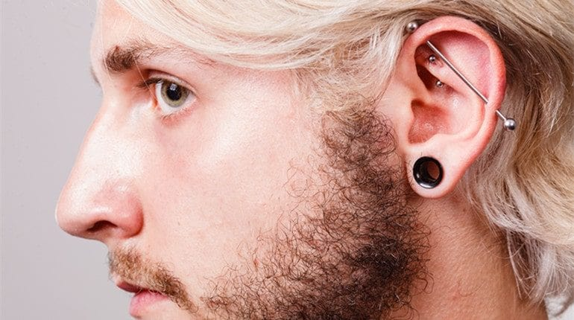

One of the most appealing aspects of ear tunnels is the freedom to express your individuality. The availability of different shapes, such as spirals, teardrops, or geometric patterns, provides endless possibilities for customization. Whether you prefer a minimalist look or something more intricate, there's a flesh tunnel design to match your style. While ear tunnels are primarily a form of body jewelry, they also serve a practical function. As your ear piercing stretches, you can easily swap out your tunnels for larger sizes, allowing you to achieve the desired gauge over time. This versatility is part of what makes flesh tunnels such a popular choice among body modification enthusiasts. The process of stretching your ear piercings is a personal journey, and it's important to take it slow.

Rushing the process can lead to discomfort and complications. With the right ear stretching kit, you can safely and gradually achieve the size you desire while showcasing your unique style with various flesh tunnel designs. In addition to their aesthetic appeal, ear tunnels have gained popularity for their comfort. Unlike traditional earrings, flesh tunnels do not have a post that goes through the earlobe, reducing the risk of irritation or pressure on the piercing. This comfort factor makes them a preferred choice for many. Flesh tunnels, also known as ear stretchers, are more than just body jewelry; they are a form of self expression and a means of gradually stretching ear piercings. These versatile accessories come in various materials and designs, allowing wearers to choose a style that suits their individuality. With the right ear stretching kit and a patient approach, you can safely achieve your desired gauge while adding a unique touch to your appearance with different flesh tunnel designs. So, if you're looking to showcase your style and make a statement, consider exploring the world of flesh tunnels.