**Detailed Analysis On The Real Military Dog Tags**

In recent years, a significant shift in fashion and personal expression has emerged, capturing the eye of many. At the heart of the trend lie genuine military dog tags with elaborate embossing, granting individuals a distinctive avenue to showcase their uniqueness. These unassuming pieces have traversed their utilitarian origins, becoming tokens of self expression and style. These dog tags, originally forged for identification in the military domain, have seamlessly transitioned into the civilian realm. Custom military dog tags, bearing unique engravings, have grown to be a hallmark with this evolution. People have embraced the opportunity to imprint their personalities on these tags, turning them into statements of individuality. From meaningful dates to motivational quotes, the scope for creativity knows no bounds. The allure of embossed military dog tags is based on their timeless appeal. The tactile sensation of running one's fingers on the raised, intricate designs adds a supplementary dimension to these accessories. Check out the below mentioned site, if you are looking for more information about [real military dog tags](https://thedogtag.co/).

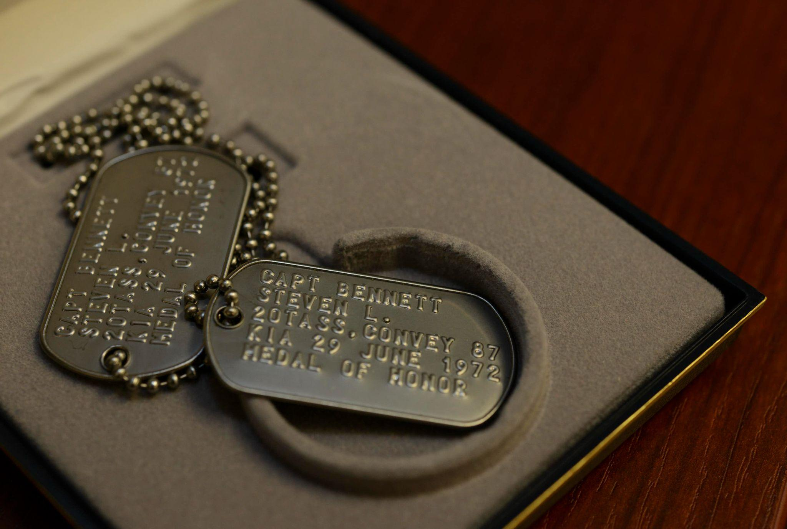

This distinctive texture sets them apart from conventional flat tags, lending an air of authenticity that resonates deeply. The desire for authenticity has steered individuals towards real military dog tags, seeking the genuine article as opposed to imitations. The weight, the sturdiness, and the annals encapsulated within authentic tags provide a link with a rich heritage. The appeal lies in owning a tangible little bit of history, a memento that encapsulates the spirit of dedication and sacrifice. Ordering dog tags has turned into a seamless process, because of the digital age. Online platforms have emerged, enabling easy customization and order placement. The era of waiting in long queues or navigating labyrinthine bureaucracies is really a thing of the past. With a few clicks, everyone can craft their particular tag, infused with personal meaning, and have it delivered with their doorstep. The versatility of those tags can not be overstated. They appeal to diverse preferences, from minimalist designs that exude elegance to bold engravings which make a statement. The spectral range of possibilities implies that dog tags interest an extensive demographic, transcending age and gender boundaries.

In essence, the desire for genuine military dog tags, now transformed into a canvas for personal expression, has captured the collective imagination. Their transition from the regimented world of the military to the free spirited realm of civilian fashion underscores their universal appeal. With customizations that speak volumes about individuality, embossed textures that evoke connection, and authentic origins that echo history, these tags have found their way into the heart of contemporary culture. In some sort of where self expression is paramount, these dog tags stand as a quiet yet resonant type of communication. They carry stories, beliefs, and aspirations, serving as a reflection of one's uniqueness. This trend not just signifies a fashion statement but in addition reflects the human desire to stand out, to belong, and to leave an imprint on the tapestry of time.