**Detailed Analysis On The Gynecomastia Surgery**

Gynecomastia, a condition characterized by the enlargement of male chest tissue, affects many men and can result in feelings of discomfort and self consciousness. To address this issue and restore a sense of normalcy, many individuals turn to male chest gynecomastia reduction surgery, a transformative procedure aimed at rectifying this physical incongruity. This surgical intervention involves the expertise of seasoned professionals who skillfully navigate the contours of the male chest to bring it in line with traditional masculine proportions. The objective of male chest reduction is to target and remove excess glandular tissue and, in some instances, excess fat as well, resulting in a more harmonious and balanced appearance. This surgical process can significantly alleviate the emotional distress often associated with gynecomastia. Before the actual surgical procedure, a crucial step involves thorough consultations. If you are searching for more information on [gynecomastia surgery london](https://www.drhassannurein.co.uk/gynecomastia-london/), just go to the earlier mentioned site.

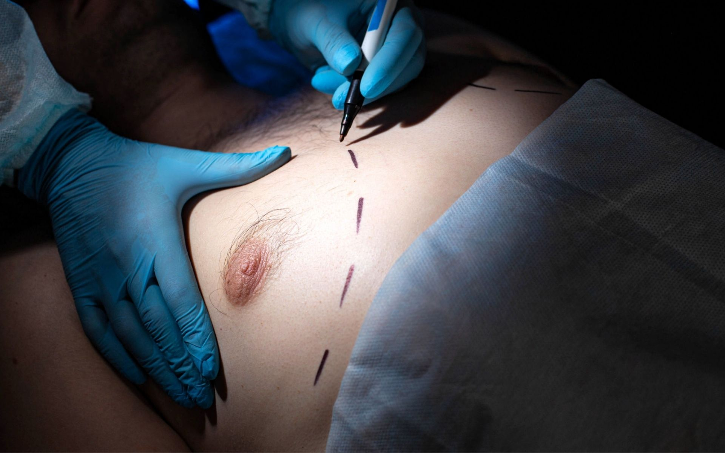

During these consultations, medical experts in the field engage with the individual to assess their unique situation. These discussions not only shed light on the details of the surgical process but also play a pivotal role in managing expectations. By understanding what the surgery entails and the potential outcomes, individuals can make informed decisions about their desired course of action. The surgical procedure itself generally spans a few hours, contingent on the extent of correction required. Administered under anesthesia, the male chest gynecomastia reduction surgery is performed with meticulous care and precision. The medical team employs techniques designed to minimize scarring, as discreet scar placement can enhance the overall aesthetic outcome and ensure a more natural appearance post surgery. Recovery following male chest reduction surgery is a gradual process that necessitates vigilant post operative care. Patients may need to wear specialized compression garments, which serve to mitigate swelling and facilitate the chest's adjustment to its newly sculpted contours.

While some discomfort is normal during the initial stages of recovery, medical professionals employ effective pain management strategies to make this phase as manageable as possible. As with any surgical procedure, there are potential risks associated with male chest gynecomastia reduction surgery. However, choosing a qualified and experienced surgical team significantly mitigates these risks, ensuring the highest standard of care and the best possible outcome. One of the prominent concerns individuals may have when considering this surgery is the gynecomastia surgery cost. The cost encompasses various factors, including the surgical procedure itself, the expertise of the medical team, and the comprehensive post operative care provided. During the consultation process, the cost aspect is usually discussed, allowing individuals to gain a holistic understanding of the financial commitment involved. Male chest gynecomastia reduction surgery stands as a viable solution for those grappling with the physical and emotional discomfort caused by excessive chest tissue growth. This surgical procedure, executed by skilled professionals, effectively reshapes the male chest to restore confidence and a sense of normalcy. With considerations of gynecomastia removal surgery and the overall cost, the decision to undergo this procedure is a significant one that requires thorough consultation, comprehensive understanding, and expert guidance every step of the way.