**User Guide On Gift Hamper Basket**

Imagine a basket that holds the key to happiness and delight that's precisely what a gift hamper is! Overflowing with a plethora of delightful surprises, gift hampers have become a popular choice for all occasions. Whether it's to celebrate a birthday, express gratitude, or simply spread some love, a gift hamper has the magic to bring smiles to faces. These delightful hampers come in various forms, catering to almost every person's tastes and preferences. From delectable chocolate hampers that ignite the senses to scrumptious food hampers that tantalize the taste buds, the options are endless. The beauty of gift hampers lies in their ability to cater to people of all ages from new mothers to adorable babies and even our beloved elderly. Chocolate hampers, with their rich, velvety indulgence, are an instant mood lifter. Browse the below mentioned site, if you are searching for additional information on [gift hamper basket](https://www.hampergifts.co.uk/).

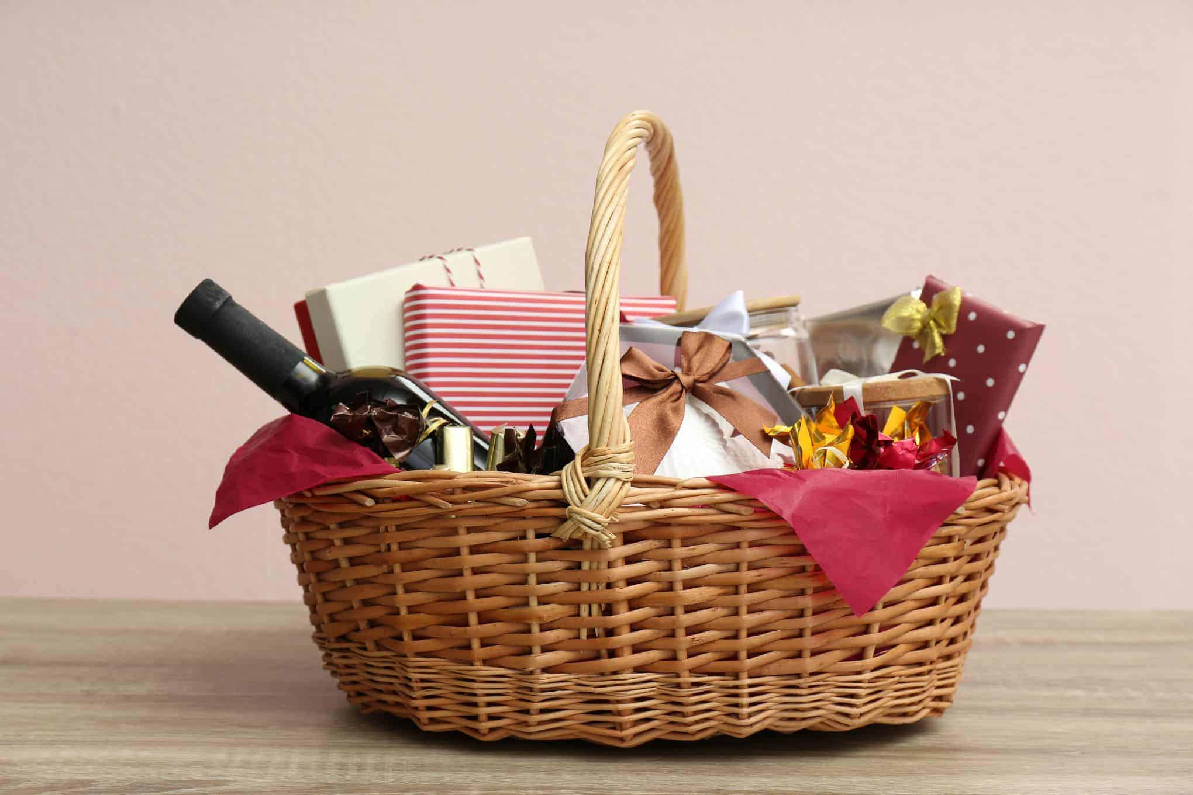

The delectable sweetness wrapped in each bite can elevate anyone's spirits. Sharing a chocolate hamper is a wonderful way to bond with loved ones, fostering connections and creating lasting memories. Food hampers, on the other hand, offer an array of delightful treats. From savory snacks to sweet delights, they are a culinary adventure waiting to happen. A food hamper brings joy not only through taste but also through the thoughtfulness of selecting the perfect combination of treats. For new mothers, a gift hamper could be a lifeline during those sleepless nights. Filled with essentials for the little bundle of joy, it shows love and support to the new parents. A baby hamper adorned with soft blankets, cute onesies, and adorable toys can make the journey into parenthood even more special. Gift hampers for elderly folks could be a way to express appreciation and care. With carefully chosen goodies like cozy socks, puzzle books, or even a heartfelt letter, it shows that they are cherished and valued.

In the world of gift giving, a gift hamper stands out because of its versatility. It provides an opportunity to curate a personalized present that suits the recipient's unique tastes. One can mix and match items, making each hamper distinct and memorable. Moreover, gift hampers also save time and effort. No need to spend hours hunting for the perfect individual gifts when you can have it all in a beautiful basket. It's a convenient yet thoughtful gesture that makes both the giver and the receiver happy. Gift hampers have also found their way into corporate settings. Employers often express gratitude to their employees by presenting them with hampers on special occasions. This gesture boosts employee morale, fostering a positive and productive work environment. A gift hamper is much more than just a collection of items in a basket. It's an embodiment of thoughtfulness, love, and care. Its charm lies in its ability to bring joy to people from all walks of life. So, the next time you're pondering over a gift, consider the magic of a gift hampering a basket full of surprises and happiness.