# **In-Depth Study On The 3PL Fulfilment**

Collaborating with a proficient third party logistics (3PL) provider is the cornerstone of a seamless 3PL fulfilment process. This strategic partnership orchestrates a flawless journey from order placement to product delivery, incorporating essential aspects like 3PL logistics, omnichannel fulfilment, pallet storage, pick and pack, and 3PL ecommerce. The 3PL provider’s expertise shines brightly in this intricate dance of logistics. They adeptly manage the convergence of order initiation and product dispatch, crafting a harmonious progression that leaves no room for errors. When an order is first received, the 3PL partner springs into action. Meticulous evaluation of product specifications, quantities, and delivery destinations takes place. This is the foundation of the operation, where data driven decisions are made for a meticulously planned process. In the sphere of logistics, planning is paramount. The 3PL partner optimizes routes and transportation modes, determining the most efficient pathways, whether it's land, sea, or air. This calculated decision making directly influences the cost effectiveness and timely arrival of goods. Are you looking for [3pl fulfilment swindon](https://abeologistics.com/)? Look at the earlier talked about website.

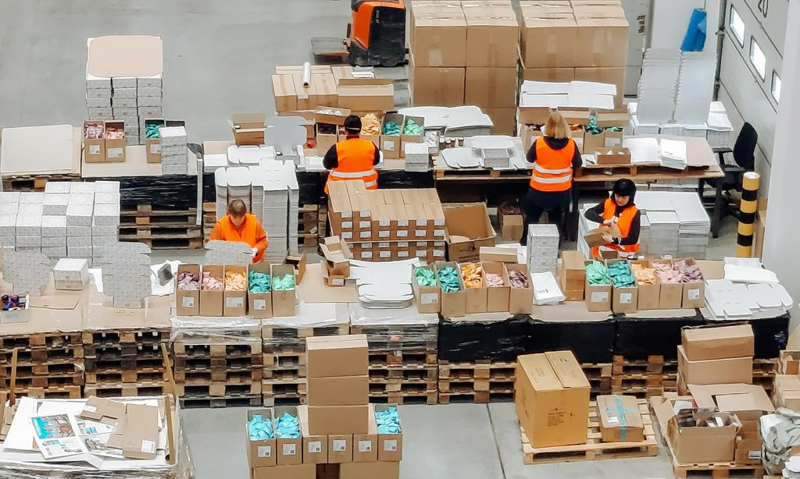

An intriguing facet is pallet storage, a vital cog in the process. The 3PL partner ensures a seamless transition from production to storage. With deft precision, each product’s unique storage requirements are met, ensuring their integrity is preserved until dispatch. As the order embarks on its journey, real time monitoring comes to the forefront. This vigilant watch ensures immediate interventions for any unexpected deviations. The 3PL partner tracks the product’s voyage diligently, preventing any disruption along the way. Communication forms a robust bridge in this entire operation. The 3PL partner keeps stakeholders in the loop, providing timely notifications about order progress and estimated delivery times. This transparent engagement mitigates uncertainties, fostering trust and reliability. Customs clearance, a potential bottleneck, is handled with finesse. Navigating through regulations and paperwork demands expertise, a forte of the 3PL partner. They navigate these intricate waters adeptly, ensuring swift customs clearance and seamless cross border transitions.

Throughout this intricate symphony, the 3PL partner remains the conductor. Their orchestration ensures the fluid flow of each phase, from pick and pack to pallet storage, culminating in successful 3PL ecommerce fulfilment. This meticulous coordination safeguards against any disruptions that could potentially arise. Finally, the product’s arrival at its intended destination is the crescendo. The 3PL partner's meticulous planning ensures the safe and timely arrival of the product. This marks the completion of the intricate process, leaving the recipient content and satisfied, a testament to the synergy of 3PL logistics. The choice to engage a knowledgeable 3PL partner resonates through the entire fulfilment journey. Their expertise bridges the gap between order initiation and product delivery. With careful planning, vigilant execution, and transparent communication, the 3PL provider navigates the complexities of logistics seamlessly. This partnership eliminates roadblocks, ensuring a smooth and efficient transition, where 3PL fulfilment, omnichannel logistics, pallet storage, pick and pack, and 3PL ecommerce converge harmoniously.