**An Overview Of Best Ear Stretching Kit**

Ear gauging, an increasingly popular practice among the younger generations, is pushing the boundaries of conventional ear piercing and elevating it to a complete new level. For those who may not be familiar with this specific trend, ear gauging involves gradually enlarging the earlobe hole allowing for the insertion of earplugs or various types of body jewelry. The end result is a bold and distinct look that's captivated the imagination of several, reflecting the diverse and ever evolving fashion choices of contemporary youth. The method of ear gauging typically begins with a traditional ear piercing, done using either a needle or a piercing gun. As individuals become more more comfortable with the style, they embark on a trip of self expression and individuality by slowly increasing how big the hole. Are you looking about [best ear stretching kit](https://www.stretchitbodyjewellery.co.uk/collections/kits)? Visit the before outlined website.

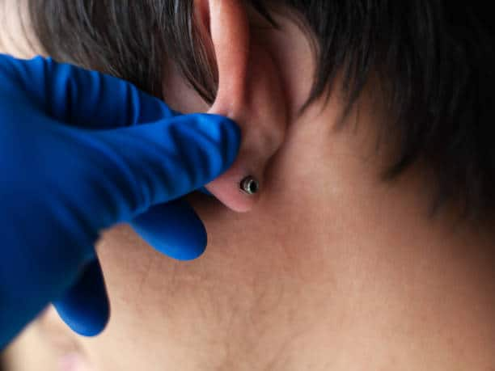

That is accomplished by carefully inserting larger gauges or plugs into the piercing, which stretches the earlobe over time. Why is ear gauging particularly appealing is the level of creativity and personalization it offers. The myriad of jewelry possibilities available in the market allows individuals to curate their collection, choosing from the vast collection of plugs created from organic materials like wood and stone to more vibrant and eye popping designs crafted from acrylic or metal. Moreover, the allure of ear gauging lies in its inclusive nature. It transcends cultural and gender boundaries, gaining acceptance in various communities and subcultures worldwide. It continues to evolve, with new styles and innovative jewelry designs constantly emerging. Consequently, an entire industry has sprung up surrounding this trend, with specialized shops and online retailers catering to the demand for unique and eye catching gauges. However, it is vital to acknowledge that ear gauging, like any kind of body modification, requires care and attention.

Maintaining clean and hygienic practices is vital to avoid infections or complications. Using top quality jewelry can also be essential to make sure a comfortable and safe experience for anyone exploring this trend. Beyond the aesthetics, ear gauging holds a further meaning for several enthusiasts. For some, it's a way to challenge societal norms and express their rebellious spirit. For others, it is an art form, making use of their stretched earlobes serving as a medium for self adornment and creativity. Since the popularity of ear gauging continues to soar, it has captured the interest of varied cultural influencers and celebrities. Ear gauging has emerged as a thrilling and influential trend that transcends borders and cultures, captivating the hearts and minds of younger generation worldwide. Its growing popularity reflects the ever changing landscape of fashion and the ability of self expression. Whether regarded as a form of rebellion or an artful display, ear gauging has turned into a symbol of individuality, creativity, and style for countless young adults over the globe. As this trend continues to evolve and make its mark on the fashion industry, a very important factor remains certain, ear gauging has left an indelible impression on the entire world of body modification and self identity.