**The Importance Of Port A Loo Hire**

Outdoor events are a wonderful way to bring people together and enjoy the beauty of nature. Whether it's a music festival, a sporting event, or a community gathering, organising such events requires careful planning and consideration. One important aspect that event organisers often overlook is the provision of proper restroom facilities. This is where portable toilets come into the picture, offering a convenient and efficient solution. It's essential to assess the number of attendees expected at the event. This will help determine the number of portable toilets needed to accommodate everyone comfortably. It's recommended to calculate the ratio of attendees to portable toilets based on industry standards to ensure an adequate number is provided. Consider the duration of the event. Longer events require more frequent servicing of the portable toilets to maintain cleanliness and hygiene. Therefore, planning the servicing schedule accordingly is crucial to provide a pleasant experience for the attendees throughout the event. If you're searching for additional details on [port a loo hire](https://www.honeywagonco.com/), click on the previously mentioned website.

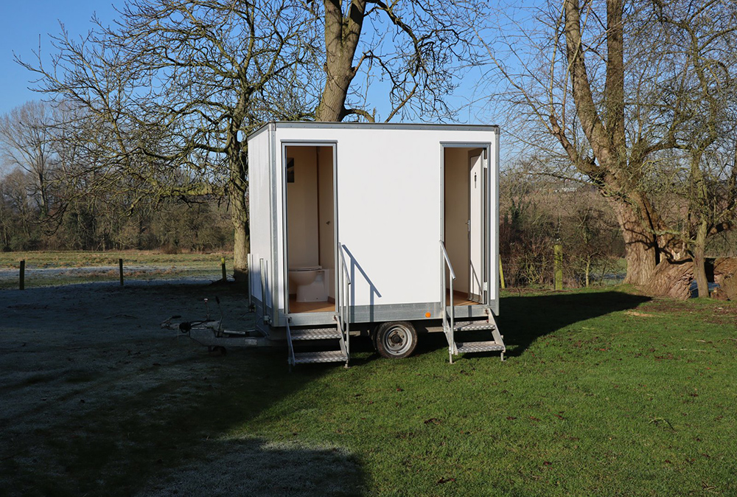

Next, evaluate the location of the event. It's important to choose suitable spots for the placement of portable toilets. Ideally, they should be easily accessible and strategically positioned to minimise any inconvenience or disruption to the event flow. Placing them near the main activity areas, such as stages or food courts, can ensure convenience for the attendees. Furthermore, consider the different types of portable toilets available for hire. There are various options to cater to the specific needs of the event. Moreover, prioritise the hygiene aspect when hiring portable restrooms. Ensure that the service provider follows strict sanitation practices and maintains cleanliness throughout the event. There are many advantages to hiring a portable loo. They offer convenience and accessibility to attendees, eliminating the need for long walks to find restroom facilities. This saves time and energy, allowing people to focus on enjoying the event. Portable toilets contribute to the overall cleanliness and hygiene of the event. By providing designated restroom facilities, organisers can prevent attendees from resorting to makeshift solutions, such as relieving themselves in public spaces.

This not only maintains the cleanliness of the event grounds but also ensures a more pleasant experience for everyone involved. Additionally, portable toilets offer privacy and comfort to attendees. They provide a personal space for individuals to attend to their needs without feeling exposed or uncomfortable. This enhances the overall experience of the event and contributes to attendee satisfaction. Portable toilets promote environmental sustainability. Many modern portable toilets are designed to conserve water and reduce waste. Planning outdoor events involves careful consideration of various factors, and one aspect that should not be overlooked is the provision of proper restroom facilities. Portable toilets offer a convenient and efficient solution, ensuring the comfort, hygiene, and satisfaction of event attendees. By following the steps mentioned above and understanding the advantages of installing portable restrooms, event organisers can create a successful and enjoyable outdoor event experience for everyone involved.