**Event Production Services - Identify The Truth About Them**

Organizing an event can be a fascinating endeavor, allowing you to tap into your imaginative side by crafting an unforgettable experience for your guests. The art of event planning goes beyond mere logistics; it involves meticulous attention to detail, seamless coordination, and an innovative touch that sets your event apart. Whether it's a wedding, a corporate gathering, or a social celebration, event planning opens a world of possibilities to create something truly extraordinary. The key to successful event planning lies in envisioning a unique and captivating experience for your guests. It starts with understanding the purpose and desired atmosphere of the event. Are you aiming for a formal affair or a casual gathering? Once you have a clear vision in mind, it's time to embark on a creative journey. Creating a captivating ambiance is crucial to leaving a lasting impression. Lighting plays a vital role in setting the mood. Imagine an elegant soirée bathed in soft, warm hues, or a lively celebration illuminated by vibrant, energetic colors. Each choice contributes to the overall atmosphere, subtly guiding your guests' emotions and engagement. If you are seeking for more information on [event production services](https://www.justsmile.co.uk), check out the mentioned above website.

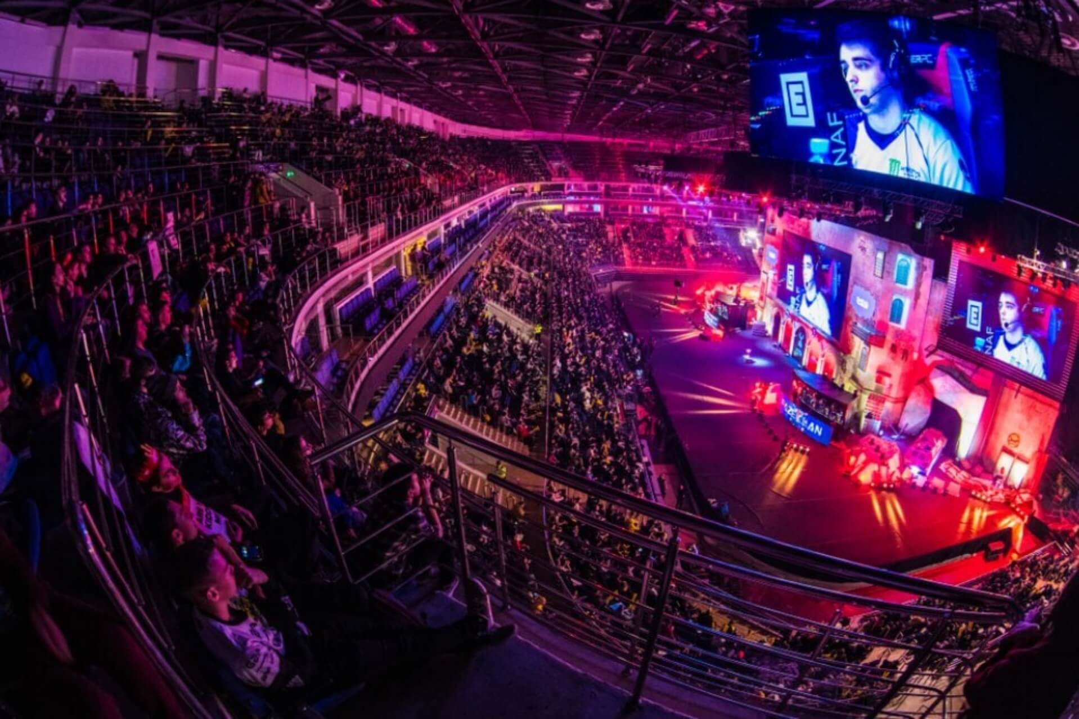

Music is another essential element that can elevate the event experience. Whether it's a live band, a DJ, or carefully curated playlists, the right melodies can transport your guests to a world of enchantment. Consider the tastes and preferences of your audience, tailoring the playlist to ensure everyone feels included and entertained. Food and beverages are an integral part of any event, and they offer an excellent opportunity to showcase your creativity. Think beyond the standard fare and explore unique culinary delights. Presenting a variety of delectable options, from bite-sized hors d'oeuvres to visually stunning desserts, will delight the taste buds and enhance the overall experience. An often overlooked aspect of event planning is incorporating interactive elements that encourage guest participation. Engage their senses with interactive displays, art installations, or even temporary tattoos. These interactive experiences create memorable moments and foster a sense of connection among attendees. Surprise and delight your guests with unexpected touches throughout the event.

Incorporate elements that provoke curiosity and evoke wonder. For instance, hidden nooks with photo booths or secret gardens can provide a delightful escape from the main festivities. While creativity is paramount, effective event planning relies on seamless coordination. Attention to detail is crucial in ensuring every aspect of the event comes together flawlessly. From coordinating vendors to managing timelines and logistics, meticulous planning is the backbone of a successful event. Lastly, as an event planner, it's essential to remain adaptable and responsive to the needs of your guests. Flexibility allows you to address unexpected challenges and ensure a smooth flow of the event. By envisioning a unique atmosphere, incorporating sensory elements, and focusing on meticulous coordination, you can create an unforgettable experience for your guests. Remember, the key lies in embracing your creativity and letting your imagination soar, allowing you to orchestrate an event that will leave a lasting impression. So, seize the opportunity and embark on a remarkable adventure as an event planner extraordinaire!