**User Guide On Custom Light Up Signs**

In today's vibrant and dynamic world, personalised neon signs have become increasingly popular due to their ability to add a unique touch to any space. These mesmerising lights have a wide range of uses, allowing individuals to express their creativity and personality in various settings. Let's explore the diverse applications and versatility of custom neon lights. One of the most common uses of personalised neon signs is for home decor. Whether you want to create a cosy atmosphere in your living room or add a touch of glamour to your bedroom, a custom neon light can do wonders. With a vast array of colours and designs available, you can choose a sign that complements your interior style and enhances the overall ambiance of your living space. Custom neon signs are also popular in the realm of business. Many establishments utilise these eye-catching lights to attract customers and create a memorable visual experience. Browse the following website, if you're searching for more information concerning [custom light up signs](https://3dneonsigns.co.uk).

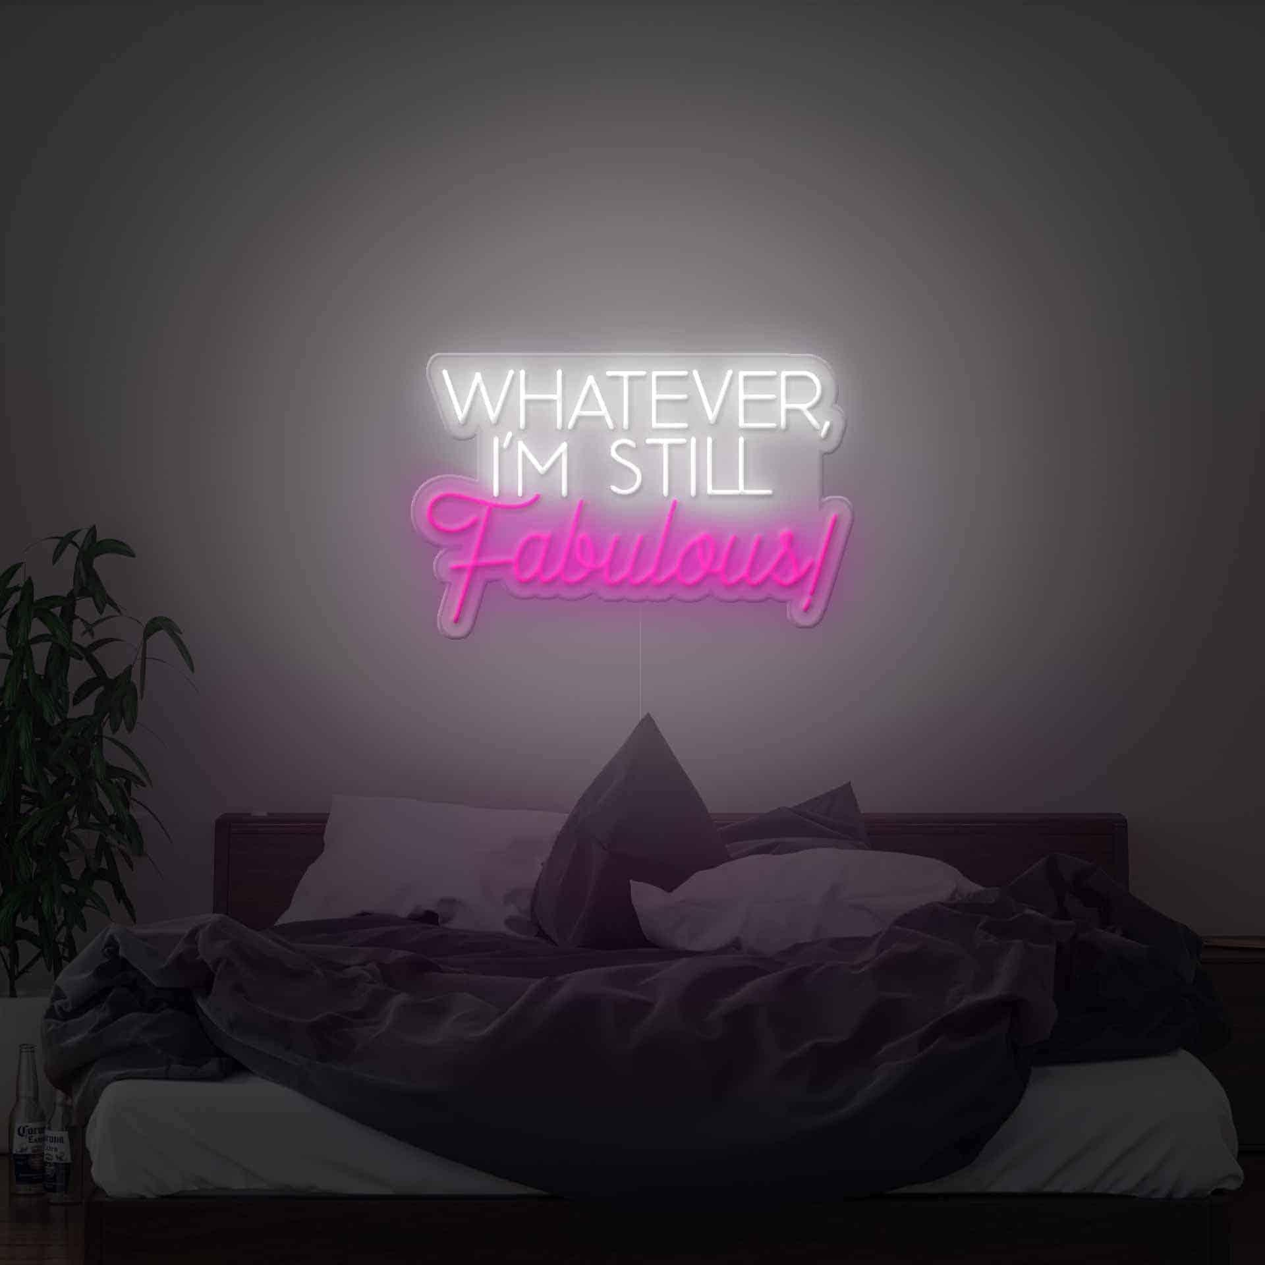

A neon sign with the name of the establishment or a catchy slogan can make a lasting impression on potential customers, enticing them to enter and explore what's inside. Moreover, personalised neon signs can be used to highlight specific areas within a business, such as a VIP section or a special promotion, effectively drawing attention to these features. Beyond personal and commercial use, custom neon lights have found their place in special events and celebrations. From weddings to birthday parties, these luminous signs can add a touch of enchantment and make the occasion truly memorable. Whether it's displaying the couple's names in elegant cursive or illuminating the dance floor with vibrant colours, personalised neon signs bring an element of fun and excitement to any festive gathering. Another fascinating application of custom neon lights is in artistic and creative projects. Artists and designers use neon signs as a medium for expressing their ideas and concepts. These lights can serve as powerful visual elements in galleries, exhibitions, and installations, captivating viewers and evoking emotions.

The versatility of neon allows artists to create intricate designs and shapes, and even incorporate various forms of art, such as sculptures or paintings, into the sign itself. In addition to their decorative and artistic uses, personalised neon signs can also serve practical purposes. For instance, a custom neon light can be a helpful wayfinding tool in large establishments or public spaces, guiding people toward specific areas or exits. Additionally, neon signs with safety messages, such as "Exit" or "Fire Escape," ensure that individuals can easily locate emergency exits and navigate through spaces in case of an emergency. Personalised neon signs have gained popularity due to their versatility and ability to enhance various settings. From home decor to businesses, and special events to artistic projects, these luminous signs add a touch of uniqueness and create visually captivating experiences. Whether you're looking to express your personal style, attract customers, or add an artistic flair to a space, a custom neon light offers endless possibilities. Embrace the enchanting glow of personalised neon signs and let your imagination shine.