**Detailed Look On Natural Tea For Menopause**

Herbal teas have gained immense popularity in recent times, and it's not hard to see why. With their natural ingredients and numerous health benefits, they offer a refreshing alternative to traditional teas and coffee. Many women, in particular, have turned to herbal teas for their various health benefits, including easing period cramps, improving digestion, and boosting their overall wellness. The great thing about herbal teas is that there are so many different varieties available, each with its unique properties and benefits. Whether you prefer ginger, chamomile, or lavender, there's a herbal tea out there for everyone. Herbal teas can benefit a range of people with its immense potency. When it comes to period cramps, many women suffer from severe pain and discomfort during their menstrual cycle. If you are one of these women, you may want to try herbal teas as an alternative to traditional painkillers. If you are looking for additional info on [natural tea for menopause](https://mothercuppatea.com/collections/mother-cuppa-tea-wellness-collection/products/hydrate), look at the earlier mentioned website.

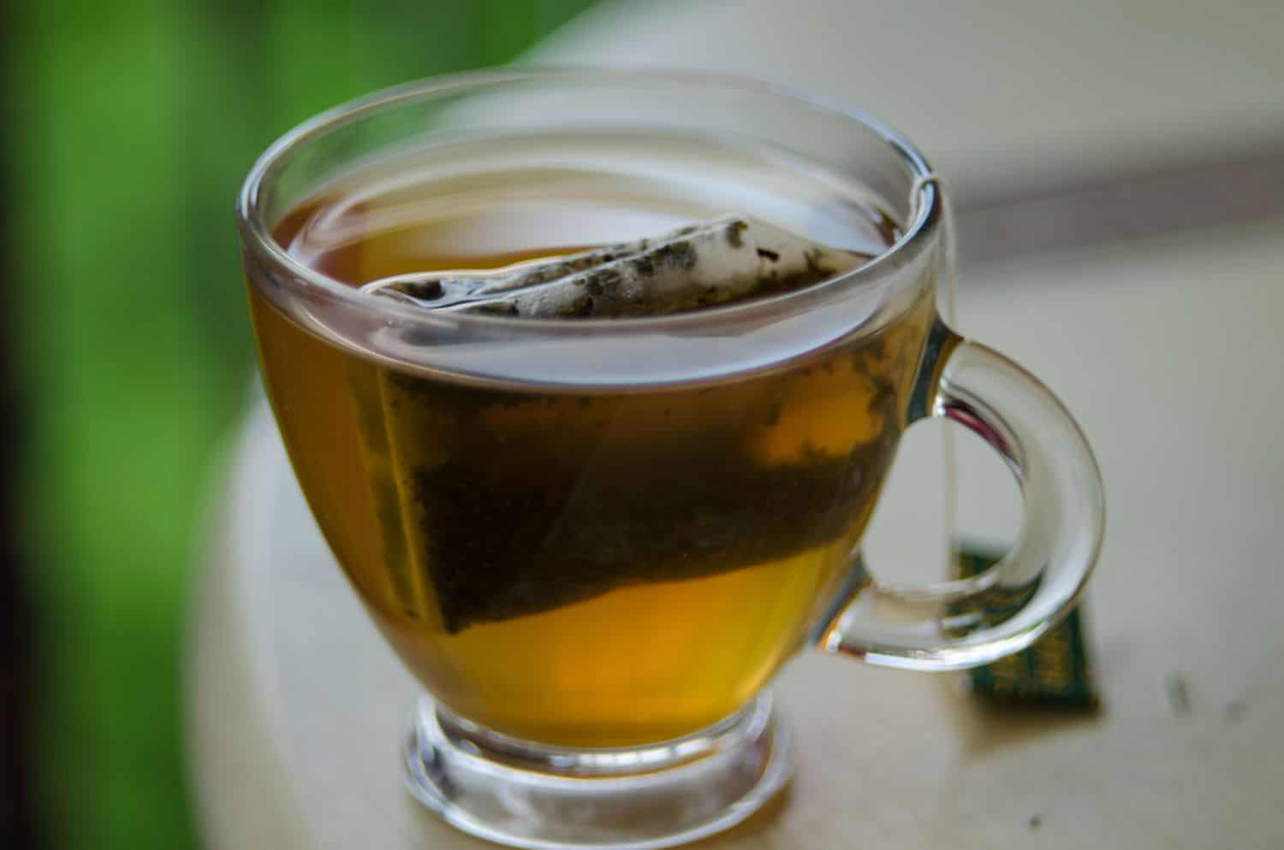

Many herbal teas, such as ginger and chamomile, contain natural antiinflammatory properties that can help to ease the pain and discomfort associated with cramps. These teas can also help to relax the muscles, which can reduce cramping and make you feel more comfortable. But the benefits of herbal teas extend beyond just period cramps. They can benefit women in many other ways. For example, some teas can help to improve digestion and reduce bloating. Others can help to boost your immune system and protect against illness. There are even teas that can help to improve your skin health and reduce the signs of ageing. One of the great things about herbal teas is that there are so many different varieties available, and each one offers unique benefits. For example, green tea is great for weight loss and can help to reduce the risk of heart disease.

Peppermint tea can help to soothe an upset stomach and improve digestion. And lavender tea can help to promote relaxation and reduce stress. If you're looking to improve your overall wellness, incorporating herbal teas into your daily routine is a great place to start. Not only are they delicious and refreshing, but they can also provide a wide range of health benefits. From improved digestion to reduced stress levels, there are many reasons to opt for herbal teas over traditional teas and coffee. Herbal teas are a fantastic alternative to traditional teas and coffee, offering a variety of health benefits for women. Whether you're looking to ease period cramps, improve your digestion, or boost your immune system, there's herbal tea out there for you. Give them a try and see how they can benefit your health and wellness. With their natural ingredients and various health benefits, herbal teas are a great addition to any woman's daily routine. So, go ahead and indulge in a cup of herbal tea today!