**A Peek At Decorative Wall Panels**

Enhancing the visual appeal of a room is a desire shared by many homeowners. One effective way to achieve this is through the use of wall panelling. Wall panels have gained recognition for their ability to add a touch of uniqueness to any living space. Their versatility, charm, and ability to transform a room's ambiance make them a popular choice among interior designers and homeowners alike. The beauty of wall panelling lies in its ability to create a focal point within a room. The panels serve as an eye catching feature that draws attention and instantly elevates the overall aesthetic. Whether it's a traditional, contemporary, or minimalist style, wall panels offer a versatile design option that can be tailored to suit any decor. The installation of wall panels allows for the introduction of texture and depth to an otherwise plain and monotonous wall. The panels come in a variety of designs, from intricate patterns to simple geometric shapes, offering endless possibilities for customization. With their visually appealing patterns and textures, wall panels effortlessly create a sense of visual interest and dimension, breathing new life into dull spaces. If you are searching to learn more about [decorative wall panels](https://www.panellingdirect.co.uk/), check out the earlier mentioned site.

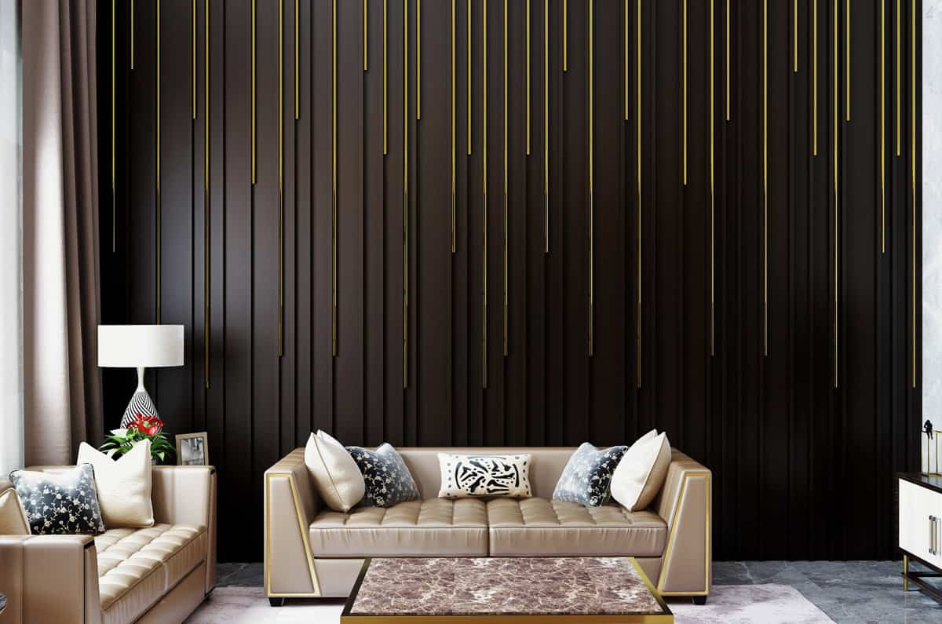

Moreover, wall panelling can help to create a harmonious and balanced atmosphere in a room. The strategic placement of panels can provide an illusion of height or width, making a small space appear more spacious and inviting. Conversely, in larger rooms, wall panels can help to break up the expanse of bare walls, creating a more intimate and cosy setting. By playing with the arrangement and design of the panels, one can easily manipulate the perception of space and achieve the desired aesthetic outcome. In addition to their aesthetic benefits, wall panels also offer practical advantages. They act as an extra layer of insulation, helping to regulate the temperature within a room. This can contribute to energy efficiency, reducing heating and cooling costs. Furthermore, wall panels can help to improve acoustics by absorbing sound, making them an ideal choice for spaces where noise reduction is desired, such as home theatres or bedrooms. Maintenance and upkeep of wall panels are relatively simple, requiring minimal effort.

Most panels are easy to clean and can withstand everyday wear and tear, making them a durable and long lasting investment. Unlike wallpaper or paint, which may need frequent touch ups, wall panels retain their beauty and charm for years to come. Whether used in residential or commercial spaces, wall panelling offers an array of benefits that extend beyond mere aesthetics. The use of wall panels presents a unique and effective way to enhance the appearance of any room. With their versatility, visual appeal, and ability to create a focal point, wall panels offer endless possibilities for customization and design. From creating an illusion of space to improving insulation and acoustics, wall panels have become a popular choice among homeowners and designers seeking to elevate the ambiance of their living spaces. Embrace the transformative power of wall panelling and let your walls speak volumes about your style and personality.